**FINE ART**

**(IPS)**

**INTERGRATED PRODUCTION SKILLS**

**STUDIO TECHNOLOGY**

**INTERGRATED PRODUCTION SKILLS (IPS) FINE ART**

Fine art refers to the visual means of conveying a message, or it’s the human skill of creating beauty through painting, designing etc.

Fine art allows students to express, represent and communicate emotions, moods, ideas, experiences, thoughts and feelings.

**TYPES/FORMS OF ART**

* VISUAL ART. This is the type of art that is perceived visually. E.g. drawings, paintings, crafts.
* PERFORMING ART. This is the type of art that deals with action and movement of body parts to convey artistic expressions through Music Dance and Drama (MDD)
* **Liberal art:** this is a form of art which is represented in form of reading, writing and debating or making analysis e.g. poetry, literature, philosophy, history etc

**UNITS/BRANCHES IN ART**

Fine art is not one way folded, it’s divided into seven units namely;

1. Drawing and painting from still life. This is the art drawing and painting a composition from manmade objects/ artificial objects e.g. tables, chairs, utensils.
2. Nature study. This is the art of drawing and painting compositions from objects that exist naturally e.g. animals, landscape, plants, trees, mountains etc.
3. Study of a Living person/ human figure. This involves the study of a human body or human anatomy.
4. Imaginative composition. This is imagining of a composition from a given topic and painting it in color. The composition can go from past experiences, fiction, present situations etc.
5. Graphics. This is the art of arranging visual images and words to communicate a message. Or it’s the designing of letters with illustrations. Examples of graphic art include; book covers, posters, magazines, labels etc.
6. Crafts/ studio technology. This involves the making of crafts e.g. pots, mats, sculpture, baskets etc. A craft is an art work skillfully made by hand by changing workable materials from their original state to a functional state for example changing clay into a pot.
7. History art and appreciation. This is the study of how art and design started from the prehistoric era to the present time.

**IPS FINEART EXAMINABLE PAPERS**.

**CATEGORY A**

1. Paper 612/1. Studio technology theory. This is a compulsory paper.-*2hours*
2. Paper 612/2. It’s a combination of still life and nature study. *2 ½ hours*
3. Paper 612/3. Study of the human figure. *3hours*
4. Paper 612/4. Original imaginative composition in colour. *5hours*

**CATEGORY B**

1. Paper 612/5. Graphic design Craft A *5 ¼ hours*
2. Paper 612/6. Craft B Studio technology practical. *5 ¼ hours*
3. Paper 612/7. History of art and appreciation. *2 ½ hours*

**NOTE:** ***In category A, candidates will select ANY TWO in addition to 612/1 compulsory while In category B, candidates will select any ONE making it FOUR (4) registered papers.***

**REASONS WHY WE LEARN FINE ART IN SECONDARY SCHOOLS.**

1. To preserve culture and tradition.
2. Source of employment and income.
3. Helps students develop their creative power/ talents.
4. It helps in coordinating other subjects for example biology, geography etc.
5. It’s a strong medium of expression and passing of information.
6. Since art involves group work. It teaches students ideas,
7. materials and methods of working together.
8. It trains students to be resourceful to the environment which they can use e.g. raw materials like papyrus, fiber, sisal, grass, clay etc.
9. To pass exams and have further studies.

**ELEMENTS AND PRINCIPLES OF ART**

These are the building blocks used to create an art work.

**ELEMENTS OF ART**

These are visual symbols artists use to create visual art, or the guidelines followed during the construction and appreciation of an art work or the essential aspects in an art work.

**IMPORTANCE OF ELEMENTS OF ART**

* They describe the characteristics of a given work of art
* They help analyze the success or failure of a particular art work
* They help us speak a common language as we communicate through art.
* They help in the production of an art work.
* They are the foundation tools on which all Art is built without which Art is non existent.

1. **Line.**

A line is a continuous mark made on a surface to join one or more points. Or a mark made by a moving tool when its point of contact is made to move.

**TYPES OF LINE.**

1. Horizontal lines
2. Vertical lines
3. Diagonal lines
4. Circular lines
5. Zigzag lines

Lines vary in character; they may be continuous, broken, thick, bold, faint, long, short, parallel, straight and curved.

**USES OF LINE**

* Lines enclose shapes,
* Define forms
* suggest movement,
* Create depth
* Create different moods and emotions.
* Show the effect of light and shade
* Indicate the weight of a given object
* Create texture
* Reveals areas of emphasis in a design
* Organize space by separating or dividing
* Used to connect different objects and ideas.

1. Space

This is the empty place or surface within or around a given work of art.

Space can be negative or positive. Negative space is the area around and between the subjects of an images. Positive space are the masses of the object.

1. **Shape.**

This is an enclosed area with well-defined boundaries or the outline area of a figure.

Types of shape

* **Organic shapes/Irregular/ free-form shapes**

These are shapes that are derived from organic objects such as plants, rocks, animals, clouds etc. these shapes are found to occur naturally in the environment and they are unpredictable and flowing in appearance.

* **Geometric shapes/ Regular shapes.**

These are shapes with regular dimensions which can be measured and drawn indifferent scales e.g. circles, squares, rectangles, triangles, semi-circles e.t.c.

1. **FORM**

This is the roundness of a given object in three dimensional space, mass and volume. Form in two dimensional art creates a three dimension aspect of height, width and depth.

1. **Structure**

This is the general appearance of an object according to its inner mass or it’s the buildup of a given object structure is formed by a combination of different forms to get the entirety of a given art piece.

1. **Color.**

This is the appearance of an object due to the reflection of light. In order to see color, light rays fall onto the surface of an object which has a pigment, and this helps the eye to realize the color of specific objects.

**SOURCES OF COLOUR**

* **Light**
* **Pigments.**  This is the coloring matter in objects.

**PROPERTIES OF COLOUR**

Colour from pigments has three main properties namely;

* Hue
* Value
* Intensity

1. **Hue.**

This is the property of color that makes it differ from another i.e. it’s the shade of color e.g. red, blue, e.t.c. Hue is the name of colour in its pure form and it can be categorized differently on a color wheel.

**Categories/ schemes of color on a colour wheel.**

A colour wheel is a basic aid that has different arrangement of colour to help an artist choose colour schemes to suit a given painting. The different categories of colour include;

1. **Primary colours**

These are colours that cannot be obtained by mixing other colours i.e. red, blue and yellow

1. **Secondary colours.**

These are colors produced by mixing two primary colors i.e.

BLUE +RED = PURPLE/VIOLET

BLUE + YELLOW = GREEN

RED + YELLOW = ORANGE

Therefore, PURPLE, GREEN and ORANGE are secondary colors.

1. **Tertiary colors.**

These are colours produced when a primary colour is mixed with a secondary colour

1. **Neutral colors**

These are colours that change/ enhance the tone/ value of other colours, and these are Black and WHITE.

1. **Complimentary colours.**

These are colours that lie directly opposite each other on the colour wheel e.g. blue is opposite orange and therefore blue and orange are complementary colours

1. **Cool colors.**

These are associated with things like water, vegetation, space, distance and the sky. Cool colors can be used to create feelings of coolness, sadness, calmness and despair e.g. blue, green, purple

1. **Warm colours.**

These are usually associated with sources of heat and light such as fire and sun. Warm colours are used in compositions to create feelings of warmth, anger, activity and life e.g. red, orange, yellow and adjacent colours on the wheel

1. **Tone/ Value.**

It refers to the lightness and darkness of a colour

1. **Intensity (chroma).**

This is the purity and saturation of colour. This intensity can be altered by adding black or white

Uses of color

* Describe form
* Modal form and create illusion of depth
* Suggest movement
* Express ideas and feeling i.e create mood.
* Arouse emotions

1. **TEXTURE.**

This is the roughness and smoothness of a surface. Or it’s the surface quality of an object.

**Types of texture**

* Tactile texture: this is the type of texture experienced by touch
* Visual texture: this is the type of texture only experienced by sight e.g a drawing of a stone, the texture can be interpreted as rough by our eyes but the paper remains smooth when you touch it.

**Uses of texture**

* It can be used to define shape,
* highlight form,
* create the illusion of space and depth,
* make a surface appear lively, interesting or dull,
* Create visual harmony with other elements around.
* Texture creates visual reality and identification of objects

1. **VALUE/TONE.**

Tone is the lightness or darkness of an object due to the effect of light or the variation of light on an object. Tones are got by manipulating a given medium to show the dark and light parts of an object achieved by controlling the value.

Value is the degree of lightness or darkness of a surface. It can be created on a surface by two techniques

1. **Shading.**

This is the process of darkening a surface. By shading the value of a colour is lowered and this is achieved by adding black.

1. **Tinting.**

This is the process of lightening a surface to increase the ability of the surface to absorb light. By tinting the value of a colour is raised and this is achieved by adding white.

The movement or variation of a shade from the darkest point through the mid shades to the lightest point is known as ***Tonal variation or gradation.***

**PRINCIPLES OF ART**

These are the guidelines used to arrange and organize the elements of art in order to produce a satisfactory piece of Art work.

1. **Balance.**

This is the state of equilibrium between elements used in a composition. This allows every item or unit on a surface to have a degree of attraction. Balance has been categorized into;

1. **Symmetrical/formal/passive balance.**

This is a type of balance that is achieved when the opposite parts of a given art work in respect to the vertical or horizontal axis are exactly or nearly the same. Balance across the middle creates formal unity in a composition and guides a feeling of stability and uniformity.

1. **Asymmetrical/informal/active.**

This is a type of balance that does not weigh equally on both sides of an art work i.e. balanced by elements which are not identical.

1. **Radial balance.**

This is a type of balance where the elements are equally distributed from the centre to the outer area; the centre becomes a potential focal point. Radial balance can either be symmetrical or asymmetrical.

1. **Rhythm.**

This refers to the visual movement in an art work i.e. a flowing movement having a regularly repeated pattern or elements of art such as line, form, texture and colour.

How to achieve rhythm

1. **Repetition.**

Rhythm can be achieved by repetition of similar elements which are placed together at regular intervals throughout the composition.

1. **Alternation.**

This is created by arranging elements to follow each other alternatively e.g. an angular shape and circular shape may be alternated both in shape and size.

1. **Progression.**

This is achieved when the flow of elements gradually changes in a sequence. Forms appear in an orderly sequence which creates rhythm and movement.

1. By manipulating the pose portrayed in a given artwork especially if the objects are in a natural setting.
2. **Dominance/emphasis.**

This is developing a point of interest in an artwork, it can be achieved in the following ways

1. Contrast. Stronger tones dominate weak ones
2. By using shapes. Bigger shapes always dominate smaller ones.

*It is the making of an area stand out in a composition.*

1. **Proportion.**

This refers to the relationship of parts of something as compared to another. It is used in a composition on how different forms relate to each other in a natural setting e.g. size of the human head as compared to `the leg

1. **Harmony.**

This refers to the relationship of elements i.e. how they relate to each other in shape, colour, tone, texture and value. The closeness in the relationship between these elements binds the composition together and gives the elements a feeling of togetherness.

1. **Unity.**

This is the harmonious balance of elements in such a way that they create the effect of oneness in the composition.

1. **Contrast.**

This is the juxtaposition of different elements in a composition. It creates excitement and interest, and often draws the eye to certain areas in an artwork.

1. **Perspective**. This is the illusion change in shape, size and form created by objects due to the effect of distance. Perspective is used to create a feeling or illusion of depth on a two dimension surface. This makes objects that are closer to the viewer appear bigger than those at a distance.
2. **Variety** is created when different elements are displayed in composition so as to break monotony and create excitement.

**HOW TO CREATE PERSPECTIVE**

1. By Overlapping

This is when one object close to the viewer covers part of a nearby or second object.

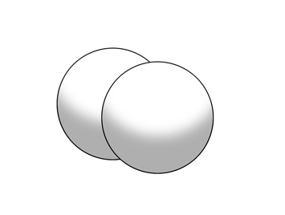

1. By Size variation.

Near large objects are made to seem closer to the viewer than smaller objects even though there on the same level.

1. By Placement.

Objects in the foreground seem to be closer to the viewer than those in the background.

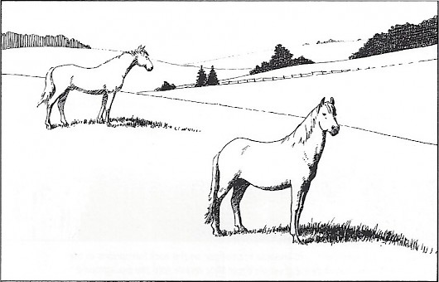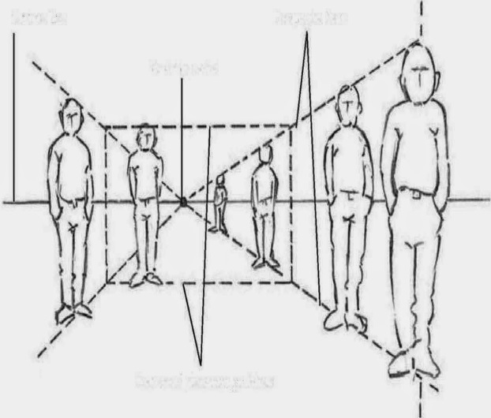

1. By Colour and Tonal variation

Colours in the foreground or closer to the viewer are darker than those at a distance or in the background.

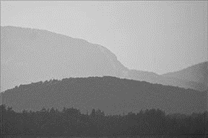

1. By Detail.

Objects with clear and strong detail seem to be closer than those without clear details.

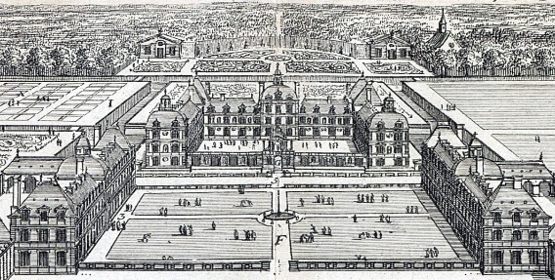

**TYPES OF PERSPETIVE**

1. Linear perspective. It’s a type of perspective viewed from the side or a flat surface.

**Types of linear perspective**

Linear perspective is both one point and two point perspective.

1. **One point perspective**

It’s the type of linear perspective where receding objects seem to disappear or meet at a single point.

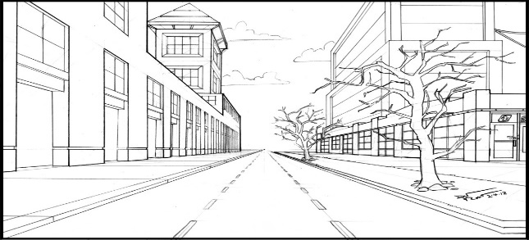

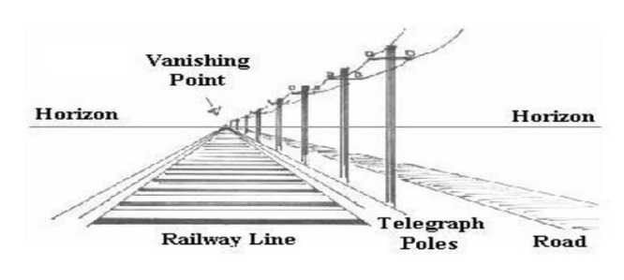

1. **Two point perspective.**

It’s a type of linear perspective with two vanishing points.

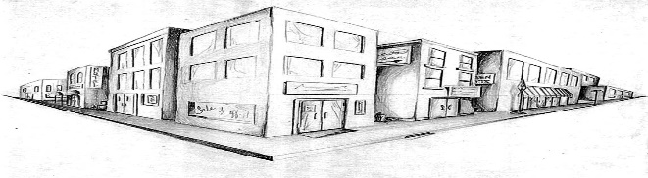

1. Three point perspective.

This is a type of one point perspective with three vanishing points.

Vanishing point is a point where all lines in the same plane disappear or meet.

1. Aerial perspective. This is the types of perspective as viewed from above or below the eye level.

**DRAWING AND PAINTING**

Drawing refers to the process of making marks on a surface to produce visual images.

**Materials/ media in drawing.**

**Dry media**

* Crayons
* Pencils
* Charcoal
* Oil pastels
* Coloured pencils
* Chalk

Wet media

* Water colours
* Paint
* Ink
* Powder colours
* Earthen colours

Supports in drawings

These are surfaces where drawing takes place.

* Papers
* Walls
* Wooden panels
* Ply wood
* Canvas

**Stages in drawing**

There are various stages in drawing which may or may not lead to the major composition, and these include;

* Sketch, this is the preliminary quick drawing done to capture something that is of interest to the artists.
* Study, this is the process which involves observation of a specified part of the object and how each relates to another.
* Finish. The drawing is carried out as specified and expressed on a surface.
* Whenever an object or a composition is set before you, the first step is to take observation. Look at the object critically; analyze the flow of lines which will give you the shape of an object.
* Study the effect of light on the object.
* Move around the setting and choose the position where the composition can be easier for you to draw from.
* Check on the proportionality of the objects and plan on how to handle your paper i.e. portrait or landscape.
* Make the sketches using thin lines to define the shape of the object. While sketching, make demarcations by using HB pencil on the area of darkness.
* After the quick sketches, build the forms by borrowing the idea from your sketches. It is important to concentrate on observation and drawing. Keep your eye more on the object you are drawing than the drawing itself.
* Find out if by drawing this, you are giving what is required of you by the examiner.
* Having finished the drawing, apply the general tone i.e. giving a lighter tone across all the parts of the object.
* Intensify the tone by shading while aware of the effects of light and the texture of the object.
* Finally, apply the finishes by adding further touches like the base and background.

Types of drawing

* Memory drawing; this is the type of drawing which has been expressed in the past and retained in the memory of an artist.
* Imagination; This refers to the art of forming mental images of what has never been seen.Drawing from imagination may be similar to that of memory because you may create new images or ideas by combining previous experience.
* Observation; this is the kind of drawing where an artist closely looks at an object and observes its particular characteristics and qualities. Drawing from observation develops the students’ awareness of anything they come across in the environment. It also enables us to develop the awareness of the surface quality of objects like the lines, texture and tonal values brought about by light.

**Types/ categories of observation drawing.**

* Still life. This is the art drawing and painting a composition from manmade objects/ artificial objects e.g. tables, chairs, utensils
* Human figure. This is the study of the human anatomy.
* Nature. This is the art of drawing and painting compositions from objects that exist naturally e.g. animals, landscape, plants, trees, mountains etc.

**LANDSCAPE**.

This is the scenary that one sees when he/she looks at a particular section of the land or environment. The landscape has three parts namely;

* Foreground. This is the area nearer to the viewer
* Middle ground. This is the area just behind the foreground which stretches to the horizon.
* Background. This t is the area furthest from the viewer and it’s usually behind the horizon.

The landscape consists of the land and sky, the land has physical features such as water, vegetation, animals, humans and manmade structures, and the sky has the sun, clouds, moon, stars, animals and objects that fly.

**SKETCHING**

A sketch is a quick rough drawing or painting often made to assist in making of the finished work.

Importance of sketching.

* Sketching helps one to obtain the basic layout or appearance of the desired work.
* It helps in keeping records of work done and those in plan.
* Sketching helps in thinking and generating ideas necessary for the creation of an art work.
* It helps to improve the level of skill and speed at which art works are made.
* It helps one build confidence before starting off on the final work.
* Sketching is a means of expression especially during leisure time.
* Artists use their sketches to present their ideas to potential clients

**SHADING TECHNIQUES/how to apply tone and texture in drawing.**

1. Hatches/ line shading; it’s a technique of shading objects by using lines that run in the same direction.
2. Cross hatching. This is a technique of shading objects by using lines that run from different directions crossing each other.
3. Dots/stippling. It’s a technique of drawing and shading objects by use of dots.
4. Scribbling (swirls). This a technique of shading objects by using doddles or swirls. This technique is used when shading human hair, clouds and tree canopies.
5. Blending/ smudging. This is a technique of shading objects by using a very smooth tone.

**Illustration showing shading or toning techniques**

|  |  |  |
| --- | --- | --- |
| **Technique** | **Activity involved** | **Demonstration** |
| Hatches/ line shading | lines are drawn  Diagonally with consistence  One below another. They should be very close to each other. |  |
| Cross hatching | lines are drawn  Diagonally with consistence  One below another and then  Another set of opposite one superimposed on them to create  Minute diamond shapes.  More lines can be drawn vertically  And horizontally. |  |
| Dots/stippling | A drawing tool eg pencil, pen, pastel, etc is used to make numerous points or dots on paper. The closer the dots, the darker the ton, the scattered the dots, the lighter the tone. |  |
| Scribbling (swirls) | A drawing tool is held and freely moved in small circles like a whirl wind motion over an area without being lifted off the paper. |  |
| Blending/ smudging | The drawing tool is held in a very slanted position so that its nib shades over a wide area. Pressure on the tool is increased to create dark tone and reduced to create lighter ones. |  |

**STUDIO TECHNOLOGY**

Studio technology refers to the processes and techniques an artist goes through to produce and artwork involving the preparation and experimentation of different materials and tools typically in a st and udio (art room). Studio technology involves thinking, planning, selecting and manipulation of materials and tools to produce an art work.

**Studio (art room).** This is a place where art works are made from or a work place for artists

Relevance of an art room/ studio

* Learner’s creativity is greatly improved through regular contact with a variety of tools and materials.
* Learners develop their level of concentration to tasks
* Level of skills amongst learners is improved through hands on experience.
* Learners greatly improve on the basic language of art.

Characteristics/ good practices of a studio

* Regular cleaning of the studio
* Keep furniture in order to avoid commotion
* Artistic display of finished art works
* Proper storage of art works
* Avoid improper use of materials e.g painting on walls and other unauthorized surfaces.
  + Have enough space to work from and storage
  + Have appropriate furniture and work facilities
  + Adequate materials and tools
  + Be located to ensure security or property, work and materials.
  + Should have rules and regulations
  + Should have a well-stocked library with relevant books
  + Well lit with both natural and artificial light
  + Should have space for display of work
  + Must have a source of water for cleaning or preparing materials.
  + Facilities for emergencies like fire extinguishers, first aid kit
  + Should be located away from disturbance
  + Have an incinerator /rubbish dump or dust bin

**CRAFTS**

A craft is an art work skillfully made by hand by changing workable materials from their original state to a functional or decorative state for example changing clay into a pot.

**Disciplines in crafts**

* Sculpture
* Ceramics/pottery
* Collage and mosaic
* Weaving
* Basketry
* Puppets
* Masks
* Papier Mache
* Leather work
* Ornaments
* Spinning
* Fabric decoration/ textile design
* Printing
* Batik
* Stitchery/embroidery
* Tie and die
* Appliqué
* patchwork

**TYPES OF CRAFTS**

The types of crafts are grouped into basic categories according to the use and the final product.

1. Functional crafts. These are crafts made for use in daily life. Example of crafts in this category include; pottery, basketry, weaving, leather work.
2. Decorative crafts. These are crafts made for decorative purposes, and these include; mosaic, collage, sculpture, pottery, basketry, masks.
3. Textile crafts. These are crafts made from textiles, and these include applique, batik, tie and dye, crocheting, embroidery, knitting.
4. Fashion crafts. These are crafts made from jewelry e.g. earring, bangles, necklaces etc.

**WHY WE STUDY CRAFTS**

* Understanding the theory behind the making of a given craft adds value to the artwork as well as giving confidence to the artist i.e. to acquire basic knowledge in various crafts.
* To understand the historical development of a given craft, the materials, tools as well as the methods and techniques used to execute a given artwork.
* Gives learners a foundation to make crafts and explain the process and steps.
* Craft work develops and masters skills of craftsmanship relevant to the crafts.
* Develop the ability of understanding and utilizing the materials within our environment.
* Think imaginatively and creatively
* To preserve culture and tradition, one demonstrates awareness and appreciation of cultural arts through active participation.
* Through crafts we learn to communicate with others in a nonverbal way.
* Helps us to live harmoniously in a society by developing a sense of self-reliance.
* Craft work helps us to occupy leisure time with a beneficial activity.
* Through exhibitions of craft work, we get exposed and share knowledge with other artists.

**IMPORTANCE OF THE CRAFTS IN OUR COMMUNITY.**

**1.** Crafts are income generating activities.

2. Industry is the source of employment.

3. Some crafts serve as a source of tourist attraction.

4. Most crafts are used for decoration.

5. Some crafts are used as home appliances like pots, baskets etc.

6. Crafts are used for study purposes**.**

**7.** Some crafts are used for entertainment like masks, puppets etc.

**HINDRANCES TO THE GROWTH OF CRAFTS**

* Materials used to make crafts are hard to get
* Industrial made materials are expensive
* Few people appreciate crafts
* Creates conflict with religion, taboos and culture
* Takes time to execute and finish.
* Lack of galleries to keep art works
* Poor custody of books and knowledge.
* Government policy of failing to set up vocational schools to train artists.
* Poor attitude towards Africans art
* Lack of knowledge of application
* Competition with modern art.

**MATERIALS AND TOOLS CRAFTS**

* A material is an item/ media that forms an art work. Materials are usually part and partial of a finished article. Examples of materials used in making crafts include clay, paint, paper mache, cement etc.
* Tools are devices used in the making of an art work. Tools help in the making of the work but are not part of the finished work. E.g. cutters, paint brush, knives, chisel, needle e.t.c.

**USES OF MATERIALS**

* Materials form the physical body of the artwork.
* Materials provide hands on practice which helps learners develop their practical skills
* Learners develop a sense of touch as they practice with different materials
* Learners improve on the creativity as they experiment with different materials
* Materials act as a medium of expression in art and design
* Learners appreciate nature as they explore and experiment with different materials from nature
* Learners develop a sense of belonging to the society as they share materials with each other.

**ADVANTAGES OF USING LOCAL MATERIALS IN CRAFT WORK**

* Local materials are very cheap compared to other materials used in craft
* They can be available in nearly every location
* They are used to make varieties of craft like pots, cups, plates, tiles, bricks, charcoal stoves, baskets, mats.
* The products made out of local materials in most cases are very expensive compared to machine work therefore fetching some money to the craftsmen.
* The products made out of the local materials preserves the culture of people who make them.

**DISADVANTAGES OF USING LOCAL MATERIALS IN CRAFT WORK**

* Some products made out of local materials like clay can break easily
* The process of preparing some materials is hectic and time consuming.
* The process of making some craft work using the local materials make people dirty especially clay work
* Dusts that come from some materials like clay can cause deadly diseases.
* Some products made out of local materials do not last longer.
* There is limited market for the products made from the local materials due to their high prices.
* The modern technology is overweighing the local way of making craft work

**KEY FACTORS TO CONSIDER WHILE MAKING A CRAFT (FACTORS USED TO JUDGE THE SUCCESS OR FALIURE OF A GIVEN CRAFT)**

Several factors can be considered while making a craft besides the elements and principles of art to judge the success or failure and these include;

1. **Message.**

Art being a language, one has to ensure that one comes up with a subject matter and the theme in order to communicate a message which should be interpreted by the observer.

1. **Creativity.**

This is the ability for someone to come up with something new. It is judged by the way one forms the different parts of the craft. It depends on how one combines the elements and principles of art to create a unique and impressive composition.

1. **Composition.**

This is the ability to put together, arrange and organize the elements of art following the principles of art.

1. **Structure.**

This is judged by looking at how different forms stand out to define the inner mass of the entire craft, showing the relationship between different parts.

1. **Use of materials.**

Use of materials is judged by the way one uses a material to create a unique piece of art work e.g. if a craft piece develops cracks, such would be interpreted as poor use of materials.

1. **Finish.** Once the craft has been created, it must be treated so that it lasts.
2. **Style and individual technique/ personal quality.**

This is judged with a unique way that makes ones work stand out more prominently as compared to others.

***MULTI-MEDIA AND MIXED MEDIA CRAFTS.***

Mixed media refers to the work of visual art that combines various traditionally distinct visual art media for example canvas painting combines paint, ink or collage work with cereals, fibres, leather stones etc.

Multimedia is the work of art that combines both visual and non- visual elements such as recorded dance, music, visual art or design.

**MOSAIC**

**Mosaic** is the art of creating images with assembling one type of small pieces of material such as coloured glass, stones or other materials on a surface or it’s a decorative design produced by arranging together one type of small pieces of hard colored material such as stone, tile, glass etc on a surface.

Materials used in a mosaic are called tesserae, the only variation is in the size and colour of the tesserae.

Mosaic is an art work that utilizes a single type of tesserae to create a consistent design which has a natural network of spaces running throughout the work called interstices

**Types of mosaic**

The type of mosaic depends on the tesserae used to produce the mosaic e.g

* Paper mosaic
* Stone mosaic
* Glass mosaic
* Banana fiber mosaic
* Leather mosaic etc.

**Materials**

Mosaic offers an unlimited exploration of different types of materials available in the environment. However, the basic materials needed include;

* Supports. A good support in mosaic depends on the type of mosaic to be produced; in paper mosaic a stiff card, mounted canvas, plywood can be used. In stone and glass mosaic, cement or a plaster base is needed.
* Glue
* Tesserae i.e. coloured glass, stone, banana fiber, paper, beads, seeds etc.
* Vanish

**Tools**

* Hummer
* Nails
* Glass cutter
* Knifes
* Pair of scissors

**METHODS USED IN MOSAIC**

* Direct method
* Indirect method
* Double indirect method

**DIRECT METHOD**

This method of assembling mosaic work involves directly placing (gluing) individual tesserae into the supporting surface.

**Advantages of direct method**

* This method is well suited to surface that have three dimensional quality such as vases
* It suits small projects that are mobile and transportable (portable).
* The resulting mosaic is progressively visible allowing for any adjustments to the colour or placement.

**Disadvantages of the direct method**

* The artist must work directly on the chosen surface which is not often practical especially for long periods of time especially for large scale projects
* It is difficult to control the evenness of the finished surface .this is of a particular importance when creating a functional surface such as a floor or table top.

**INDIRECT METHOD**

This method involves applying the tesserae facing down to a temporary surface eg glue using an adhesive and later transferred to the final surface eg a wall surface or craft project with two dimension surface, the temporary base material is then removed to reveal the mosaic topside up.

**Advantages of indirect method**

* This method is most use full for extremely large projects.
* It gives the artist time to rework areas.
* Permits the cementing of tiles to the backing panel to be carried out quickly.
* In one operation it helps to ensure that the front surface of the mosaic tile and mosaic piece are flat and in the same plane on the front even when using tiles and pieces of different thickness.
* Mosaic murals, benches and table tops are some of the items usually made using the indirect method.

**DOUBLE INDIRECT METHOD**

The tesserae are placed face up on a temporary support, when the mosaic is complete a similar medium is placed on top of it. The original underlying material then removed and the mosaic is then cast in its final base support and the temporary base material is then removed to reveal the mosaic top side up.

**Advantages of the double indirect method**

* Large works can be done this way with mosaic being cut up for shipping and then re assembled for installation.
* This method enables the artist to work in comfort of his/her studio rather than at the site of installation.
* The operator directly controls the final results of the work which is important e.g. when the human is involved.

**Disadvantages of the double indirect method**

* It requires great skill on the part of the operator to avoid damaging the work

.

**STRENGTH AND WEAKNESS OF MATERIAL USED FOR DESIGNING MOSAIC**

**1. PAPER**

**Advantages of using paper for mosaic**

* Easy to acquire and available in plenty in most areas
* Easy to use by cutting or tearing into any form or shape as deemed fit by the artist
* They adhere to different surface unlike other materials like stone, tiles. Papers are versatile.
* Papers are flexible and light they can easily be changed without distorting a big area .papers allow mistakes to be corrected easily.
* Papers appear in a variety of colours and can be printed on or immersed into solutions to change colour.
* Papers are light which makes them suitable for portable mosaic articles.

**Weakness of paper**

* There not suitable for outdoor projects as there fragile to humidity and wet conditions
* Papers are not strong hence less desirable
* Papers cannot be used for architectural furnishing.

**2. MARBLE/STONES**

**Advantages of marble stones**

* Durable, they last longer than papers
* Good for outdoor articles and projects
* Have a shimmering effect due to the minute space networks
* No special furnishing like framing and protective spray is required.
* Good for humid and wet conditions
* There good for architectural designs

**Weaknesses of marble stones**

* Expensive making them difficult to acquire
* Exist in particular areas and locations making them not readily available.
* Heavy in terms of weight limiting portability of pieces or work (not mobile)
* There not suitable for small tiny projects

**3. PLANT FIBERS (banana fibers)**

* Light in terms of weight which makes them suitable for mobile articles
* Readily available and not expensive
* Easy to prepare and cut
* Available in a variety of tones
* Good for indoor decorations
* Easy for beginners

**Weaknesses of plant fibers**

* They’re not versatile on surface i.e. walls
* They need to be dry to provide neat and even surface
* Not durable like marble and stones
* Not easily removed from surface in case of mistake to replace or correct mistake

**4. LEATHER**

**Advantages of leather**

* It’s durable and long lasting
* They are an accommodative to indoor and outdoor projects
* Have interesting texture
* It allows polishing by waxing or rubbing with a soft brush for shiny surface.
* Leather can be embossed allowing designs to be added on the surface to create more patterns

**Weaknesses of leather**

* Drying leather is difficult it takes time
* It needs to be moisture to render it soft and usable.
* Difficult to cut into small tesserae and require special tools
* It needs skill, time and concentration to stick or apply it on given surface
* Leather is expensive to acquire
* Leather is not readily available.
* Leather produces heavier articles than paper

**5. STONES AND PEBBLES**

**Advantages of stones**

* There durable they can last the taste of time.
* Stones have an interesting texture and patterns if used.
* Stone can take on different colours.
* Stones are good and suitable for outside decorations i.e. pavements
* Stones are suitable for wall and floor decorations
* The can be cut into different sizes
* They reflect light and can create shinny surface

**Weakness of stones/pebbles**

* Stones are expensive
* Stones and pebbles require special tools to be cut into manageable shape and size
* Not suitable for mobile articles
* Stones require expensive adhesives like cement and plaster.

**Techniques and process**

The techniques of making mosaic depend entirely on the materials and method to be used, the basic steps include;

1. Collect and prepare the necessary materials
2. Select a theme and make sketches of the composition of the mosaic on paper and suggest the colors to be used/followed
3. Transfer the sketch on to the support
4. Carefully apply glue to the support as you paste the tesserae following the sketch.
5. Trim off unwanted parts, vanish and frame it to finish.

**PROCEDURE OF MARKING A MOSAIC WORK**

The following are the steps followed in making a mosaic work

* **Preparation**

This involves conceiving the ideas which can be physically or in the mind of the artist.

* **Gathering material**

Prepare the surface, glue, cutter materials to be used e.g. banana fibers, glass, stones

* **Sketching /preminary drawings**

Make different sketches and design patterns on the surface to be worked upon using a pen, permanent marker, pencil, chalk etc.

* **Preparation of materials**

Cut the materials into small tiles (cubes) tesserae or tear according to different patterns and colour strength or marble to cause texture.

* **Executing the work**

Carefully add glue any other adhesive in use to a small piece (tesserae) and apply to the work surface following the patterns of the composition guided by the tones.

**NB** start with the dark areas by applying dark coloured tesserae and control the tones to light until when the composition is covered.

* **Filling process**

Cover all the elements in the composition and then the back ground and fore ground plus all the spaces that might have been left bare.

* **Finishing**

Finish the work and furnish i.e. depending on the materials used this may include varnishing, framing, reaming off excesses to give an impressive finish. Hang the work or display .lastly tide up or clean up the work area.

**IMPORTANCIES OF THE MOSAIC ART WORK**

* Mosaic serves a decorative purse i.e. wall hanging, pavement celling’s, floors etc.
* Mosaic work communicates the feeling and ideas to the viewers
* Mosaic work has an economic value when sold it’s a source of income.
* Mosaic works are designed to embrace events.
* Mosaic murals are used as campaigning mediums.
* Mosaics are educational materials used as teaching aids and examination able crafts.
* Mosaic work improve and enhance the creative abilities of the artists.
* Mosaic picture reserve, promote and embrace cultural activities and beliefs.

**CHALLENGES FACED BY PEOPLE PRODUCING MOSAIC WORK**

* Shortage in availability of materials especially traditional materials due to the changing environment and modernization.
* Expensive materials for example glass, marble stone slates, ceramic tiles etc.
* Limited knowledge and skill about mosaic production
* Very few people appreciate art and mosaic work which limits the market for mosaic article.
* Some mosaic materials are scarce there not easily accessible in some areas.
* Stiff completion from other pictorial crafts like printed photos, camera photos, drawings and paintings.

Limited technologies of producing large quantities of mosaic work in shorter time

**COLLAGE**

This is an art work produced by assembling/arranging different materials or text on a surface to form a composition.

The most important feature of collage is the exploration of the surface textures of materials and how they interplay with each other.

**Types of collage**

**Montage**

It refers to the process of composing pictures out of miscellaneous elements such as magazines pictures, torn up into specific shapes and sizes pasted on a surface. The pictures are juxtaposed to create an unusual composition

**Photo montage**

This involves the use of photographs to create a composition. The photographs can be cut up or used as a whole.

**Materials**

* Supports
* Adhesives
* Textured materials such as tissue paper, newspaper, magazine paper, fabrics, fibers, wool, cotton, maize, bamboo, wood, saw dust, metals, sand, sea shells etc
* Vanish

**Tools**

* Hummer
* Nails
* Glass cutter
* Knifes
* Pair of scissors

**Technique**

1. Collect the different materials to be used
2. Select a theme/motif and make sketches of the suggested idea on paper
3. Transfer the sketch onto a hard support
4. Carefully paste materials on the support using a good adhesive following the composition sketches
5. Varnish the collage to preserve different materials, frame it when complete.

**Differences between a collage and a mosaic art work**

1. Collage places emphasis on the textural qualities of different materials while mosaic is made up of tesserae of one type of material.
2. Materials in a collage overlap each other to produce paint like effects while a network of minute spaces running in different directions is produced in a mosaic.
3. Mosaic is tone based i.e. tesserae are arranged to provide tonal variations in a picture composition whereas college is texture based derived from the different materials used.

**SCULPTURE**

This is a 3 dimensional artwork that express ideas, feelings and experiences. It is derived from a Latin word **sculptura** which means to carve (sculpt) or to cut out a shape from a material e.g. wood, stone e.t.c.

**COMPOSITIONS /ELEMENTS OF SCULPTURE**

1. **Solids.**

These are 3 dimensional masses which occupy spaces, they are areas occupied by the main body

1. **Voids.**

These are spaces which are partially or fully enclosed by planes. Voids are the negative spaces through a sculpture or depression while solids are positive masses.

1. **Planes.**

Planes refer to the area of a surface which is defined by a more or less abrupt change in direction; a plane can be flat or curved. In sculpture several flat and curved planes are organized in different directions to create a unified form.

1. **Contours.**

These are the outlines of objects in spaces. They are also junctions of planes.

1. **Texture.**

This refers to the surface quality of the sculpture.

1. Color

**Principals of design in sculpture**

Principals of sculpture are just as important as in other areas of art and design, these include

* Balance
* Dominance
* Repetition
* Proportionality
* Movement
* Contrast
* Harmony

**Balance.** This is the state of stability/ equilibrium of a sculpture.

The two most important aspects of balance in sculpture are;

1. Balance that makes sculptural form stable

A sculpture must be made stable to stand without toppling over when placed on or stands on the ground.

1. Balance of attraction created by arrangement of elements i.e. planes, voids, contours, texture and colour.

The proportion of masses and voids help to make a sculpture stable, visually and physically. If asymmetrical balance is used, the sculpture must carefully be planned so that it is both stable visually and physically.

**Movement**

Movement refers to the rhythm of the sculptural form and can be along vertical, diagonal, or horizontal planes..

**Contrast**

A sculpture can have contrast of texture i.e. (roughness versus smoothness) contrast of colour e.g. (red verses green) for example contrast of light and darkness.

Greater contrast is achieved by playing one principal against the other in different proportions. Contrast is not achieved by having equal proportions of elements.

**Unity and harmony**.

Unity, harmony refers to the overall relationship of elements and principals which gives a three or two dimensional form stability and visual interest.

**Proportionality**

It refers to relationship of parts of a sculpture as compared to another or its self.

**TYPES OF SCULPTURAL FORMS**

There are generally two types of sculptural forms i.e. realistic and abstract;

1. **REALISTIC**.

These types of sculptural forms are based on natural forms or real life situations and can be easily recognized.

1. **ABSTRACT.**

These are sculptural forms which cannot be easily recognized. They are exaggerated, reduced or enlarged in proportions (purposeful distortion).

**TYPES OF SCULPTURE**

1. **RELIEF SCULPTURE**.

This is a type of sculpture where images project from a surface. The images are carved out of the surface and rely on the base or plane to support them. Relief sculpture is a combination of both 3 dimension and 2 dimension art forms.

**TYPES OF RELIEF SCULPTURE**

1. **HIGH RELIEF (ALTO – RELIEF).**

This is a type of relief sculpture where images project boldly. The image is almost completely carved from its surface with very little of the structure touching the base or the surface.

1. **LOW RELIEF (BAS – RELIEF).**

This is a type of relief sculpture where the projection is slight, the image barely extends past the base e.g. images on a coin.

1. **SUNKEN RELIEF (INTAGLIO).**

This is a type of relief sculpture where the image projects or is carved into a surface so that its highest projection is below the surface.

1. **SCULPTURE IN THE ROUND**.

This is a type of sculpture that exists independently in a complete 3-dimensional from and not attached to a support or a background, it can be seen from all corners.

1. ARHITECTURAL SCULPTURE
2. CERAMIC SCULPTURE

**Terms used in sculpture**.

**Armature**

It is an internal frame work designed to support the material used in making the body of sculpture i.e. paper, clay, wax, plaster of Paris. Or a frame work (skeleton) of a sculptue, it’s usually made of flexible materials like wires to support the body of the sculpture.

**Marquette**

A Marquette (French word for scale model) is a small scale model or rough draft of a sculpture to represent a bigger project of sculpture.

**Assemblage**

An assemblage is a sculpture constructed from found objects .typically an assemblage does not disguise the original objects used, rather it either tries to show them in a new light, or forms a figurative sculpture from a collection of shape.

**Pedestal**

Is the base on which a freestanding sculpture is mounted so as to stand. It can also be built as part of the sculpture from below.

**METHODS PRODUCING SCULPTURE**

1. **ADDITIVE**.

This is a method that involves the addition of materials to build up a form to the required composition. There are two main processes/ techniques of the additive method;

1. **MODELING**.

This is the process of building up form from malleable materials such as clay, plaster of paris, plasticine, papier mache, wax etc.

1. **CONSTRUCTION/ ASSEMBLING.**

This is the process of building up form by assembling or fitting together materials. These materials can be joined together by welding, nails, glue, stitching etc. the materials which may be used are; wood, metals, stones, plastics, gourds, leather, fabric etc

1. **SUBTRACTIVE METHOD**.

This method involves cutting away of parts of a mass of material until the required shape (form) is created. Carving (sculpting) is the main technique used in the subtractive method. The materials used in carving include wax, soap, wood, stone and clay.

1. **CASTING.**

This is a method of producing three dimensional forms by pouring liquid or molten materials into a mould that gives the required shape.

A mould is a device used for shaping material in molten or plastic state into the required form.

**TYPES OF MOULDS**

1. **Press mould.**

This is a mould that shapes materials in plastic state

1. **Slip mould.**

This requires the use of slip or any molten material.

**How to cast forms using the slip mould**

1. Select a theme and a source of inspiration
2. Make a sketch and Design the sculptural form.
3. Collect and prepare the materials and tools to be used.
4. Make the mould which is going to be used for casting from plaster of paris because it has the ability of absorbing water quickly from clay.
5. Prepare slip by mixing finely ground clay with water to a light cream consistency
6. Fit the pieces of moulds together and pour slip into the channels of the moulds and allow the moulds to stand for a period of time.
7. The moulds will absorb the excess moisture from the slip and a thin layer of clay will form on the inner walls of the moulds and will take on their shape. As the clay dries in the mould, it shrinks in size and detaches itself from the plaster mould
8. And when the form is dry, remove it from the mould to expose the finished sculpture.
9. Decorate as required to finish

**WOOD CARVING**

Wood carving is a subtractive technique of producing sculpture by cutting or chipping away parts of wood until the required forms are made. It is called wood carving because wood is the main material that is carved into form.

MATERIALS USED

* **Wood**
* Wax
* Vanish
* Paint
* Wood preservatives
* Wood glue

**Typical wood carving tools**

* **Machete/ panga**
* **Chisel,** A cutting tool consisting of a slim oblong block of metal with a sharp wedge or bevel formed on one end with handle at the end. It is used to cut and remove parts of wood by placing a sharp edge against the wood and pushing or pounding the wood end with a mallet**.** Chisels appear in different size both small and large straight cutting edges .used for lines and cleaning up surfaces.
* **Gauge.** Gauges are round blade wood carving tools. Used to carve or cut round shaped edges. Gouges are chisels with curved blades, for scooping or cutting holes, tight channels, hallows, rounds, grooves and sweeping carves.
* **Coping saw.** A small saw that is used to cut off chunks of wood at once. A hand saw used to cut intricate external shapes and interior cuts in wood. Coping saw blades are always thicker and much coarse cutting than typical fret saw blades.
* **Clamp.** A clamp is a wood carving tool with a clasp. Used for holding and strengthening wood piece being carved in one position.
* **V. tool.** It is a tool with a v shaped cutting edge. V. tool is used to part lines and cut v-shaped channels and emphasizing lines in the process of wood carving.

* **Vainer.** A vainer is a specialized, small deep gouge with a u-shaped cutting edge for cutting u-shaped grooves.
* **Mallet.** A small wooden hammer with a big round or box head at one end and a short handle used for driving the carving tools i.e. the chisel, gouge into the wood etc.
* **Sandpaper.** A strong sheet of paper coated with sand or other abrasive material for smoothing and polishing the surface of wood sculpture especially in the difficult to reach areas.
* **Hand axe.** Hand held tool consisting of a head flattened to a blade that has one or two blades and short handle for chopping wood and roughing out.
* **Chain saw.** A chain saw is tool that has a power driven and fast revolving chain of metal teeth, usually used to fell trees and cut them into logs.

**SELECTION OF WOOD FOR CARVING**

Selection of wood for carving is a matter of personal choice, a variety of wood species can be suitable for carving. Some wood possess fine even grains and can be curved with greater ease than others.

However the woods that are less desirable possess unusual grain and coloration and can be of equal merits. There is an adequate supply of native wood available in any geographical area which can be exploited.

**Preparing wood for carving**

* Collect the desired wood for carving i.e. by looking at its texture and colour, grain configuration in a rough or finished state.
* Dry the wood off and seal the ends by painting with oil paint and dry for the second time. For large diameter logs this can take some time like a year.
* Un cured logs can be curved, although cracks or cheeks may or will develop. These can be filled with pigment bee’s wax or after the wood fillers can be used.

**Phases in wood carving**

The process of carving goes through number of stages .these include

* The inspiration stage
* Preparation stage
* Roughing out stage
* Intermediate carving
* Final finishing

**The Inspiration stage.**

This stage involves conceiving the idea for carving i.e. the object to be curved. Sketches are developed in numbers until the final is achieved.

**Preparation stage**

Prepare the log for carving i.e. by drying it first and sealing off the ends to avoid 1cheeks and cracks to develop during the process of carving. Prepare the necessary tools to used and get them ready for use.

**Roughing out stage**

This stage involves preliminary carving, removing the buck of the log if necessary, and making simple outlines of the different planes and proportions with grooves all around the outline of the object.

**Intermediate carving**

Cut away the mass of wood around the desired form leaving it raised up while the curved portion get sunken. Cut from the edge onto the outline .curve around the object giving attention to prominent parts. Continue dealing with detailed studies.

**Final finishing**

Finishing is done by using a rasp file, sand papering, waxing and painting if necessary.

Techniques/ process of wood carving

* Select a theme/ source of inspiration
* Make sketches of your composition of paper
* Collect and prepare the materials and tools to be used.
* Make a Marquette in clay to guide you through out the carving process

**Advantages of carving in wood**

* Wood is readily an available material in most parts of the country and in a variety of species.
* It good for beginners and starters
* It good for architectural design and decorations
* It is good material for stabiles and mobile sculptures
* Wood is durable if well treated with varnishing abrasives

**Limitations of wood as material for carving**

* Wood requires number of tools and other materials to be curved into sculpture which makes it expensive
* If not well treated it can develop checks and cracks during the process of carving
* Wood does not permit corrections un less a change is design. Any cut piece is irreplaceable.

**ROLES OF SCULPTURE**

Sculpture has been made for various purposes for generations in societies in Africa and other parts of the world. The following are the major roles of sculpture at present time.

1. Sculpture expresses ideas, feelings and experiences of an artist. It enables him to bring out his deep feelings and emotions.
2. Sculpture also communicates what an individual aspires to reach e.g. sculpture made about ideal beauty of form that individuals aspire to reach.
3. Sculpture plays a role of reflecting man’s activities in the society. It reflects its economy, politics, religion, culture, plants and animals.
4. It’s monumental. This type of sculpture is made to commemorate an event or someone great, such sculpture is usually big in size and significantly seen in the area where it is placed.
5. Sculpture plays an important role in conserving the culture of people. It helps to conserve history, religion, customs and economic activities of people.
6. Sculpture gives a special type of beauty in the place where it’s located.
7. Sculpture can also be used for academics, simplified to suit the artist’s interpretation of the elements and principles of art.

**CLAY**

Clay is a fine grained, firm earthly material that is plastic when wet and brittle when dry and heated. It is a refractory material capable of withstanding high temperatures without fusion or decomposition. It consists primarily of hydrated silicates of aluminum. It is a complex chemical compound which is composed of aluminum, silicon, oxygen, magnesium, potassium and iron.

**CLASSIFICATION OF CLAY**

1. **Residual/ primary clays**.

These are clays found near the original rock source; these clays are the purest type.

1. **Sedimentary/ secondary clays.**

These are clays that have been carried from their original source by water erosions, these type of clays contain a lot of impurities

**PROPERTIES OF CLAY**

1. **Plasticity.**

This refers to the elasticity of clay. Clay must be plastic in order to be worked on in any form. This allows clay to be manipulated into all sorts of shapes and can be worked to a very fine degree.

1. **Porosity.**

This is the ability of clay to absorb water, air and other fluids. This porosity allows clay to dry without cracking; however clay must be dried in a cool place to prevent rapid drying which can lead to cracking.

1. **Vitrification.**

This is the ability for clay to convert into a glass substance (vitreous state) i.e. it turns into a glass like material which is strong and hard when fired.

1. **Shrinkage.**

This is the ability of clay to reduce in size by losing its water/ moisture to the surrounding during the process of drying.

**TYPES OF CLAY**

There are many different types of clay which contain different substances to give clay their particular properties.

1. **Kaolin (china clay).**

This type of clay is nearly pure residual clay. It has low plasticity and a high degree of resistance to heat. It is used in the manufacture of ceramic tiles, toilet sinks and bath tabs. It fires to white in colour.

1. **Porcelain clay.**

It is derived from a French word “porcelain” which means cowry shells because of the similarity in colour. This is prepared clay with kaolin clay as the main ingredient used in mixing. They are fired at very high temperatures and become almost translucent.

1. **Ball clay.**

This type of clay is very plastic and is used to blend with clays which have low plasticity.

1. **Shale clays.**

This type of clay has low resistance to heat. It is the commonest type of the clays and it is used for making bricks, earthen pots etc.

1. **Earthen ware clay.**

These are porous, non-water proof, opaque and do not fire above 12000c. Traditional earthen ware clays do not vitrify because they are low fire clays.

1. **Stone ware clays.**

These are sedimentary clays which fire above 12000c. They vitrify and able to hold water even when not glazed. Many stone ware clays contain feldspar and silica which fire to a dense, non-porous state because they are able to vitrify.

1. **Tale clay.**

Tale clays contain magnesium silicate, also known as chalk, steatite or soap stone. The magnesia acts as a fusing agent at high temperatures

1. **Fire clays.**

They have low plasticity, but high resistance to heat. It is used for making fire bricks and insulating bricks.

**PREPARATION OF CLAY**

Freshly dug clay must undergo preparation before it can be used. Not all clays are the same some are more plastic than others while others can be used without adding anything. The methods used in clay preparation include;

**Plastic method**

This method makes use of the moisture available in the clay as it is delivered. If clay is too dry, water is added in order to get the right plasticity. This type of method is suitable for clays which do not slake easily.

**Steps**

1. **Mining.**

Clay is mined from its localities or deposits.

1. **Sorting.**

Impurities such as stones, roots etc are sorted from the clay.

1. **Wedging**.

Clay is then mixed, wedged and knead to plasticity; this stage involves turning and pressing clay to remove any air pockets and to make it a homogenous mass.

1. **Storage.**

The clay is then stored in polythene bags to conserve the moisture.

**Wet method**

In this method clay is dissolved in water to form slip or slurry.

**Steps**

1. **Mining.**

Clay is mined from its localities or deposits.

1. **Slaking.**

This is the process of soaking clay in water for a period of 3 to 4 days, its slaked to reduce the lamps of clay into a homogenous mass.

1. **Sieving.**

After slaking, the clay is mixed with a wooden stick into slip; it is then sieved to remove any impurities. The finely sieved clay is then put in a bucket and at this point grog or kaolin is added.

1. **Drying.**

The slip is then left to dry to plasticity i.e. to partially dry to a malleable state. Dry pieces of plaster of paris can be added to absorb the excess moisture.

1. **Wedging.**

The clay is then pressed and folded to remove any air spaces to plasticity.

1. **Storage.**

It is then stored in polythene bags to prevent it from drying.

**Semi dry method**

Clay is dried, pounded and crushed into powder form but can only be used for dry pressing.

**Semi dry method**

This method is basically a combination of dry and plastic method.

**STEPS**

1. Clay is dug from the localities rich in clay
2. Spread out the clay to dry under the sun.
3. When the clay is totally dry, Crash it into powder form.
4. Sieve the powdered clay to get rid of larger particles and impurities.
5. Soak the powder clay in to water. It should be regulated so that it does not reach the consistency of slip but the level of plasticity. Grog is then added into the clay.
6. Mix the clay, wedge and knead it to the level of plasticity.
7. Store the clay in plastic bags to preserve the moisture.

**Note**

1. The wet and semi-dry methods are suitable for making of pottery because they produce pure clay.
2. If the impurities are not removed, they can cause clay articles to explode during the firing process because these impurities have different expansion and contraction rates from clay.

**PHYSICAL STAGES OF CLAY**

1. **Green ware**

This refers to dry and unfired clay articles

1. **Leather hard**

It refers to clay that has been dried partially, at this stage the clay body is approximately 15% of moisture

1. **Bone dry**

It refers to clay bodies which are completely dry with 0% moisture content

1. **Bisque/biscuit clay**

It refers to clay after it has been fired into a kiln for the first time.

1. **Terracotta**

This is reddish brown hard backed clay

1. **Slip**

This is clay mixed with water to the level of pouring creamy state

Advantages

* Its cheap to acquire and buy
* It can be recycled before firing
* It does not require excessive processing
* It can be modeled into any shape
* It works with both the additive and subtractive techniques
* It can be easily decorated
* Its durable when fired

Disadvantages

* It is messy when working with it
* It is brittle and can easily break if mishandled
* It cannot be recycled once fired
* Cannot be used outdoors if not fired
* Its only available in swampy places

**CERAMICS/POTTERY**

It refers to the art of making and decorating pottery which is fired in a kiln to turn it into a hard brittle material.

**Materials**

* In traditional pottery, clay is the main material used.
* porcelain
* Glaze, this is a material used to give a thin shiny transparent surface to clay pots, porcelain etc

**Tools**

* Potter’s wheel
* Buckets for keeping clay
* Sieves
* Modeling tools for smoothening and decorating
* Rolling pin for making slabs
* Wedging table, to wedge and knead clay.

**TECHNIQUES AND PROCESSES OF PRODUCING CERAMICS**

**Pinch method**

This is when a lump of clay is rolled into a ball and then pinched using the thumb and fingers to form the shape.

**Steps**

1. Wedge and knead clay thoroughly until all the air is expelled
2. Take a lump of wedged clay and roll it into a ball
3. Hold the ball in the left hand and push the right thumb into the middle of ball to make a hollow.
4. Gently pinch and pull the walls of the ball while turning it around to form the required shape making sure that the walls are kept even.
5. After forming the required shape, let the work dry partially in a cool dry place
6. When the article is leather hard i.e. partially dry and no longer pliable, it can be decorated.
7. Allow the article to partially dry before firing.

**Coil method**

The coil technique involves the use of rolled up clay which is coiled and built successively upon each other to create the required shape.

**Process**

1. Wedge and knead the clay to plasticity
2. Form a uniform slab and cut out a circular shape that forms the base of the article.
3. Roll the clay on a flat surface into even sized lengthy coil pieces, equivalent to the size of a pencil.
4. Score the base with a sharp instrument and add slip to it.
5. Add coils to the base and press the inner sides of the coils to merge them to the base
6. Add more coils to the article as you form the walls of your pots. Seal all the gaps and smoothen the article as you build it.
7. When the required shape and height is obtained, smoothen the outer surface with a smooth tool, preferably the back of a spoon.
8. Dry the article to leather hard and decorate as required.
9. Allow the article to dry before firing
10. Glaze

**SLAB METHOD**

This technique is used to make pottery from rolled clay slab cut into required shapes. Angular, circular shapes can be obtained which are joined together at all sides using slip to make the required shape.

**Process**

1. Wedge and knead the clay to plasticity
2. Prepare a flat surface to work from and cover it with a polythene material
3. Get a small lamp of clay and flattened it in your hands then place it on the flat surface and make it smooth and even by using of a rolling pin.
4. Using a ruler and a knife, cut the slabs into required shapes and sizes
5. Score the sides of the slabs and join the together using slip. Smoothen them into each other at all corners, both inside and outside of the form.
6. When required shape and size have been obtained, allow the article to dry to leather hard and decorate
7. Let it dry thoroughly before firing
8. Glaze

**THROWING**

This involves the use of a wheel on which clay is placed and an article formed while the wheel is rotating. There are two types of wheels; the kick wheel and the electric wheel.

**Process**

1. Wedge and knead the clay, and make it slightly stiffer than that used in hand building techniques.
2. Throw the clay to the center of the wheel. If the clay is not centered properly at the beginning, the forms will be difficult to manipulate and will be distorted.
3. Rotate the wheel by kicking or switching on power.
4. Dip the hands in water and Cup the hands over the clay and press down at the same time. Water acts as a lubricant while working on the form.
5. Shape the clay into a cylinder using a twisting motion, moving the hands up and down the side of the form.
6. Begin to hollow the cylinder by cupping the hands around the clay and press the thumbs as far as they can go.
7. Take out the thumbs and cup the right around the side of the cylinder, and use the other hand to enlarge the hollow as the wheel rotates.
8. Pull up and shape the clay cylinder to the desired shape while rotating the wheel
9. Smoothen the pot by wetting a sponge and move it up and down as the article rotates.
10. Stop the wheel, use a wire to cut to release the pot from the wheel when the desired form has been made
11. Let the pot dry to lather hard and decorate as desired
12. Let it dry thoroughly in a cool dry place before firing
13. Glaze

**CASTING**

This is a technique of producing ceramics by pouring slip into a mould that gives the required shape.

**HOW TO CAST POTTERY**

1. Select a theme and a source of inspiration
2. Make a sketch and Design the ceramic form.
3. Collect and prepare the materials and tools to be used.
4. Make the mould which is going to be used for casting from plaster of paris because it has the ability of absorbing water quickly from clay.
5. Prepare slip by mixing finely ground clay with water to a light cream consistency
6. Fit the pieces of moulds together and pour slip into the channels of the moulds and allow the moulds to stand for a period of time.
7. The moulds will absorb the excess moisture from the slip and a thin layer of clay will form on the inner walls of the moulds and will take on their shape. As the clay dries in the mould, it shrinks in size and detaches itself from the plaster mould
8. And when the form is dry, remove it from the mould to expose the finished article.
9. Decorate as required, glaze and fire to finish

**DECORATING CERAMIC FORMS**

**Inlaying**

Ceramics forms can be inlaid with cut out shapes which can be of the same colour as the clay body. Use slip to fix these inlaid shapes to the clay article

**Incising**

Shapes can be cut into the clay form using suitable instrument.

**Sgraffito and engobe.**

The sgraffito technique is a form of scratching a design on the surface of a ceramic form. Any suitable tool can be used such as a pin, nail

**Burnishing**

When the form is leather hard, it can be polished by rubbing any smooth surface can be used e.g. a back of a spoon. Burnishing enriches the color of the article.

**Marks**

Marks can be made on the form with the fingers or with some tools.

**Impression**

Design can be created by impressing objects into moist clay forms. Patterned shapes can be used e.g. wood blocks once the impression has been made, colored slip can be brushed into the groove.

**Slip trailing**

Different colored clay slips can be slip-trailed on the surface of the ceramic forms. They can be applied by dipping, spraying, sponging or painting.

**GLAZING CERAMIC ARTICLES**

Glaze is a vitreous substance used to cover ceramic wares in order to make them attractive, durable and impervious to liquids. Glaze is applied in liquid form to green ware or bisque ware articles. When the glaze is fired it melts and fuses to the ceramic body.

**TYPES OF GLAZES**

**Transparent glaze**

This type of glaze is clear and the colour of the clay body or under glaze is seen.

**Opaque glaze**

This type of glaze is non-transparent and it obscures the fine details of the forms

**Gloss glaze.**

Gloss glazes are smooth and glass like; they are highly reflective and brilliant.

**Matt glaze**

They are porous and rough glazes

**UNDER GLAZE AND OVER GLAZE**

Under glaze is something applied to ceramic ware before glazing while over glaze is an additional coat of glaze applied to pottery after glazing.

**FIRING**

This is the process of baking ceramic articles, heat is applied to a ceramic object in a kiln in order to harden it or fix an applied substance such as glaze. During firing the clay changes from green ware to bisque ware i.e. changes from a raw material to a permanent material.

Firing produces irreversible changes in the body by sintering and fusing together of coarser particles in the body at their points of contact with each other.

**TYPES OF FIRING**

**Bisque fire**

This is the first firing of raw ceramic ware. When fired, the chemicals and water in the clay molecules is drawn out and the clay fuses together. At this point, clay will not disintegrate again to become plastic

**Glaze (glost fire)**

This is a type of firing where ceramic articles are first glazed before firing. During this firing, the glaze is transformed into a coating of glass which fuses to the clay. Wax is applied to the bottom of the glazed forms to prevent them from sticking to the kiln rack because the glaze melts during firing.

**Decorating fire**

This type of fire is used for over glazes and lusters. The over glazes and lusters are applied to bisque ware and then fired again to set the over glazes and lusters.

**HOW TO FIRE CERAMIC WARE**

Firing pottery can be done using a variety of methods, with a kiln being the usual firing method. Before firing pottery, make sure that it dries completely as green ware and bone dry. Pottery can be fired in the following ways

1. **By using a kiln**

A kiln is a specialized oven or furnace for firing clay for pottery and bricks. Kilns are heated by burning wood, saw dust, Coal, gas and electricity. Both the maximum temperature and the duration of firing influences the fired characteristics of pottery, thus the maximum temperature with in a kiln is often held constant for a period of time to soak the wares to produce the maturity required in the body.

1. **Using a pit fire clay**

This is a traditional method of firing pots. It is a low fire, and fire wares at a low temperature. Glazed wares cannot be fired because the high temperatures for glazes cannot be attained. A pit fire clay can be made in the following ways

* Dig a pit, large enough to accommodate the ceramic ware and the material to be used as fuel.
* Fill the bottom of the pit with a thick layer of saw dust.
* Pile up and arrange the ceramic ware in the pit
* Build up layers of saw dust, paper and dry wood around the articles. The wood is arranged in such a manner that enough oxygen can circulate freely with in the enclosure, add enough materials to allow the fire to burn for some time.
* Light your fire from the top and allow to burn. More wood can be added if the first lot burns too rapidly, care should be taken when adding more wood in order not to break the pots
* After the articles have attained their maturing temperature, allow the articles to cool and dig up the fired pots.

**FABRIC DECORATION**

Fabric/ textile design is patterning an essentially plain fabric to render it more appealing to serve a particular purpose. This includes any of the many concepts and activities used for enriching a fabric medium, in any case the action or technique used is a result of a design and expression of elements and principles of a design.

Fabric comes from a Latin word fabricare which means to make, to build, and to fabricate. Fabrics are made by pressing and matting fibers such as backcloth, looping, knitting, knotting, netting, braiding, plaiting and weaving. Fabric is used interchangeably with textile, cloth etc.

Textile Come from a Latin word texer which means to weave/plait. The term textile therefore means a woven fabric. These are made from perishable materials which can only survive for some time when preserved.

**TYPES OF FABRIC DESIGN**

**Surface fabric design**; this is a design that is achieved by ornamenting the surface of a fabric.

Surface fabric designs can be achieved in the following ways;

* Printing
* Painting
* Tie and dye
* Batik
* Embroidery
* Appliqué
* Patch work.

**Structural fabric design;** this is a design that is achieved as the material/fabric is made; this includes the overall design, form and shape plus all the details involved in assembling the sections of the fabric.

Structural fabric decoration can be achieved in the following ways;

* Weaving
* Knitting
* Netting
* braiding

**WHY WE DECORATE FABRICS**

* **For aesthetic reasons;** Fabrics are decorated to make a plain piece of fabric look interesting
* **For social reasons;** Fabrics are decorated to differentiate social classes
* **For cultural reasons;** Fabrics are decorated according to the culture that has been put in them. People base on historical and ancestral believes.
* Fabrics are also decorated to suite the social classes of people and also recognize companies, institutions and organizations from the way they dress and present themselves.
* Fabrics are also decorated to earn a living.
* Fabrics are also decorated for communication purposes. They are decorated especially for advertisements by different organizations and individuals

**PRINTING/ PRINT MAKING**

This is the process of duplicating a design by transferring its image from a prepared surface to another. The process is carried out in four basic methods namely

* Relief method. This is printing made by a raised surface
* Intaglio. This is printing made from sunken areas
* Lithography. This is printing made from a flat surface
* Serigraphy. This is printing made through a surface

TEXTILE/ FABRIC PRINTING

Fabric/Textile printing is the process of duplicating a design to [fabric](http://en.wikipedia.org/wiki/Textile) in definite [patterns](http://en.wikipedia.org/wiki/Pattern). In properly [printed](http://en.wikipedia.org/wiki/Printing) fabrics the color is bonded with the [fiber](http://en.wikipedia.org/wiki/Fiber), so as to resist [washing](http://en.wikipedia.org/wiki/Washing) and [friction](http://en.wikipedia.org/wiki/Friction).

In printing, [wooden](http://en.wikipedia.org/wiki/Wood) blocks, [stencils](http://en.wikipedia.org/wiki/Stencil), [engraved](http://en.wikipedia.org/wiki/Engraving) plates, rollers, or [silk-screens](http://en.wikipedia.org/wiki/Silkscreen) can be used to place colors on the fabric. Colorants used in printing contain [dyes](http://en.wikipedia.org/wiki/Dyes) thickened to prevent the color from spreading by [capillary attraction](http://en.wikipedia.org/wiki/Capillary_attraction) beyond the limits of the pattern or design

**MOTIF**

A motif is a repeated pattern used in a design during printing, or it’s a source of inspiration.

**Process of developing a design/motif**

For any printing to take place, one has to develop a motif first.

**Procedure for motif development**

* Select a theme or a source of inspiration for the design. This can be got from nature or artificial settings of still life or daily human activities, one may be inspired by textural patterns, shapes and color. For example, cabbage.
* Draw the inspiration on paper and study its shape and surface with tones. The purpose of the study is not to leave out interesting features of the object.

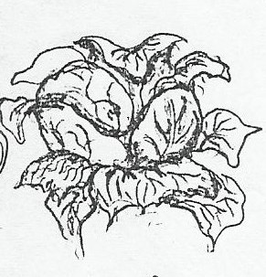

* Simplify the drawing in outlines

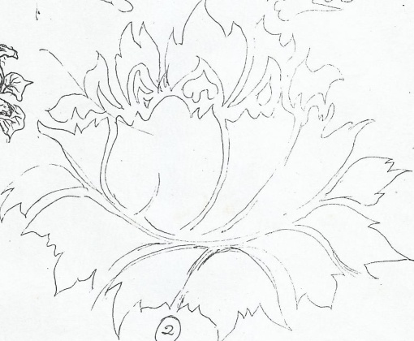

* Rearrange the object from its natural setting to your own composition while incorporating principles such as movement and rhythm so the design appears continuous when printing.

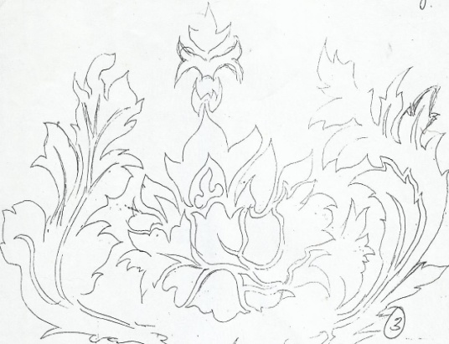

* Draw a square or rectangle to rearrange the ideas while incorporating the elements and principles of art

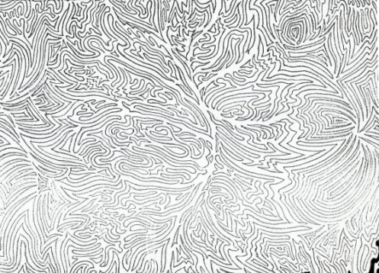

* Introduce positives and negatives by shading black for the positives to make the motif ready for printing

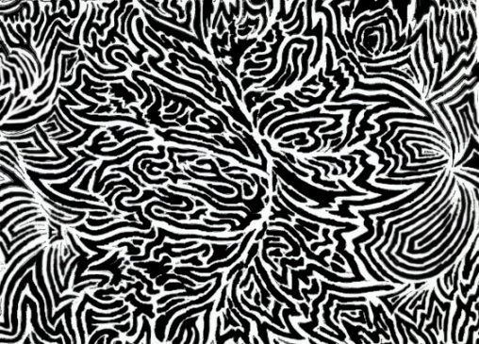

**REPEATS**

Once a pattern has been decided on, the type of repeat can be chosen. There are three basic types of repeats; the full repeat, the half drop and full drop repeat. Each type can be varied to produce interesting effects by rotating, inverting or reversing the design unit. The basic surface is divided geometrically into networks ie;

* Square net work

The unit can be repeated at equal intervals in a line both horizontally and vertically

Motifs put into side by side full repeat

Motifs put into full drop repeat

Motifs put into half drop repeat

* Diamond net work

This is made by crossing diagonal lines at regular intervals on a square or rectangle

* Semi-circle net work

This is made up of rows of semi-circles, alternate rows being staggered as in brick form

* circle net work

This is made up of rows of circles, alternate rows being staggered as in brick form

* Hexagon net work
* Octagon net work

**BLOCK PRINTING**

Block printing is a method of decorating a fabric by the use of a wooden block or linoleum-block into which a design is cut. The block is subsequently coated by thickened dye which is transferred or applied to the surface of a fabric. It’s a technique that works also in text printing, images and patterns.

**Materials**

* Fabric
* Dyes
* Thickeners

**Tools**

* Carving tools i.e. chisel
* Rubber gloves
* Dyeing utensils i.e. saucepans
* rollers
* Printing blocks

**Processes / technique**

1. Select a theme and source of inspiration for your design.
2. Develop a motif, and identify the negatives and positives
3. Trace the design on the wooden or linoleum block and using a block cutter or chisel, carve out the parts of the design that will not receive color leaving the finer parts i.e. cut out the negative areas of the design. When finished, the block presents the appearance of sunken relief or a design standing out like a stamp. If a design has two colors, then a separate block is needed for each distinct color
4. Prepare the fabric and Pin it to the printing surface and suggest repeat units
5. To print, apply printing paste to the block by Rolling out printing ink onto a flat palette, then transfer ink to the surface of your block and press it firmly and steadily on the cloth. For flow of pattern and repeats, ensure perfect registration of the motif on cloth by recognizing previous points of impression made both horizontally and vertically, when the ones on the right fall at the ones on the left and the ones on top fall at the ones at the bottom.
6. If a pattern contains several colors, dry the cloth after the first printing before the next one commences
7. After printing leave it to dry before ironing.

**Possibilities**

* It can add a simple yet intriguing effect to your item.
* It is a simple way of transferring text, patterns or images to your item.
* It’s a faster way of printing a fabric

**Limitations**

* The carving of the pattern onto the wood can be difficult, as it requires a lot of skill and a steady hand!
* It can get extremely messy with the use of paint!
* It takes time to carve a design in the wooden or linoleum block
* Once a mistake is made during carving it’s hard to correct

**STENCIL AND SCREEN PRINTING**

Stencil printing is a method of fabric design where designs are cut in a stencil and (printed) transferred to the fabric.

A stencil is a perforated sheet through which ink is forced to create a printed pattern on a surface or a sheet where a design can be cut to force ink through during printing, for example cardboards, manila papers, photographic films, x-ray films etc.

To print the pattern on a given surface, the designer applies printing paste, paints and inks through the open areas of the stencil

**Tools**

* A motif
* stencil
* Razor blades and cutters
* Sponge
* Squeegee. This is a rubber blade that is used to press printing ink through a screen to a prepared surface.
* Screen. This is a silk mesh stretched on a wooden frame.
* Masking tape

**Materials**

* Cloth, fabric
* Printing paste
* Water
* Thickeners

**Technique/process**

1. Select a theme and source of inspiration.
2. Develop a motif, and identify the negatives and positives
3. Place the paper with your motif on a flat surface table and attach/ staple your stencil
4. Cut out the positives on the stencil using a cutter or a razor blade.
5. Place the cut stencil on top of the fabric to be printed
6. Add printing paste on a sponge and press through the cut gaps
7. Repeat the motif throughout the cloth to cover it with the design
8. When done, dry the cloth in a cool dry place before ironing.

Possibilities

* It’s a cheap way of printing since it does not involve many costs.
* Three is easy registration of colour.

**Limitations of stencils**

* Cannot be used for patterns with the negatives locked up by positives
* It takes time execute, i.e. cutting the stencil
* Stencil destructs and distorts some patterns when cutting
* Uneven distribution of color on a fabric

**PHOTO EMULSION AND SCREEN PRINTING**

Photo emulsion is a fine suspension of insoluble light sensitive crystals in a colloid solution, usually containing gelatin.

TOOLS

* Screen
* Squeegee
* Printing table/ light table
* Motif

Materials

* Cloth
* Printing paste
* Water
* Thickeners

**Preparation of photo emulsion**

* Select a theme and develop a motif, and identify the positives and negatives.
* Prepare a stretched mesh on a wooden frame to form a screen
* Prepare a solution of photo emulsion
* Spread a thin layer on the screen and let it to dry in a dark place for about 45mins
* Scan the motif to a computer and print it to a transparent material for example tracing paper.
* Put the screen upside down on top of a black surface, then put your transparency with positives and cover it with a glass block
* Expose the screen to light, the light causes the emulsion to harden and bind to the screen. Where the light passes makes a solid layer and where the light is blocked by the positives, remains water soluble.
* Wash and spray the screen with water only in the areas of the positives; this clears the areas where the ink will be pressed during printing.

**Techniques**

* Select a source of inspiration/ theme
* Develop a motif and identify the positives and negatives
* Transfer your motif to the screen with photo coat/ photo emulsion.
* Prepare the materials and tools to be used.
* Lay a cloth on a printing table
* Place the screen at the starting point of printing and apply just enough printing paste on a squeegee and make the first print
* Continue the printing throughout the cloth
* When complete, Wash the screen after printing and leave the cloth to dry and iron it after

**Possibilities**

* It’s a fast way to decorate a fabric
* It can produce detailed images, rich texture and intense shading. i.e. It is also feasible to utilize actual found objects (both three dimensional and two dimensional) in the prints that have been photocopied

**Limitations of photo-emulsion**

* It is relatively expensive in terms of materials
* It solely depends on power which is not reliable i.e. power cuts are high
* It is difficult to be used by an inexperienced artist
* It’s a permanent technique which does not allow corrections during the printing process

**Factors considered in printing**

* **Creativity;** depends onhow one develops a design from known to unknown
* **Line and pattern;** the organization and simplicity of shapes, and use of several quantities of line to create pattern
* **Color;** this includes choice and harmony
* **Balance;** in terms of space, shape and color
* **Rhythm;** ability to create movement in a design
* **Craftsmanship;** registration of the motif without creating unnecessary lines in the designs and the neatness of the print
* **Purpose;** the use of the print v/s the technique. I.e. patterns (designs) with angular patterns may be used for table cloths and carpets, while patterns with intricate designs are more suitable for dresses or shirts and bigger patterns are more suitable for curtains and carpets.
* **Message;** it should have a theme to communicate a given message.

**TIE AND DYE AND BATIK**

Tie and dye and batik are resist methods of decorations i.e. dye is resisted/ stopped from spreading to certain areas of the fabric thus creating a design.

**TIE AND DYE**

Tie-dye is a bound resist method of decorating a fabric. In the process, a piece of fabric or cloth is tied and dyed typically using bright colors. The fabric is tied, folded or stitched to prevent penetration of dye.

**Materials**

* Cloth
* Dyes such as dylons
* Nylon threads
* Salt

**Tools**

* Heat source
* Flat iron or iron box
* Objects such as stones and bottles tops
* Saucepan
* Needles
* Nylon threads and rubber bands or raffia

**Methods**

1. **Gathering and folding**

This is a method in which the cloth is folded, tied and dipped in the dyes. The cloth can be folded to form pleats, strips, circles or spirals

1. **Knot tying**

Hold the cloth at both ends and twist into a long rope form, Tie this long rope into a knot and tighten as much as you can without damaging the cloth. You can tie as many knots as you have room for. Rubber bands or string can be tied over the knots to reinforce them as well as provide fine lines in the pattern.

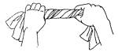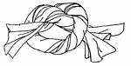

1. **Pleats**

Lay the cloth on a flat surface and fold it into small folds (pleats) this is done following the length of the cloth or diagonally from one corner of the cloth, be careful not to lose any pleats and then tie accordingly. Loop rubber bands or string very tightly around all the pleats several times and knot. You can use as many ties as you want. This useful technique is also employed in tying ovals, squares, diamonds or any shape you can imagine which has symmetry.

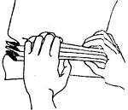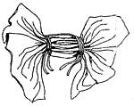

1. **Stripes**

Lay the cloth on a flat surface, gather the cloth following its length and tie it

tn_stripes_2.jpg (3714 bytes)

1. **Circles**

Pull up a point on your cloth and twist it clock wise to form an anti-hill form. Tie it from the base up-wards. This can be done at several points on the cloth. The cloth can also be tied with objects of different sizes at different at different points.

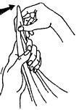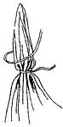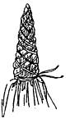

1. **Spirals**

At the middle of the cloth, pinch a part and twist it to form a curl, and tie the entire cloth

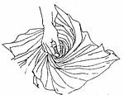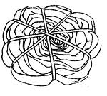

1. **DIAMONDS, OVALS AND SQUARES**

Fold the cloth once along an imaginary line which will run through the intended form. Draw half of the intended design with a pencil or with your mind's eye, starting and ending on the crease.

Form pleats, starting at one end of your line. Try to keep that line in the center between your hands while pleating until you come to the end of your line.

Wrap string or rubber bands around all the gathered pleats several times, and tie a secure knot.

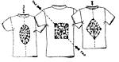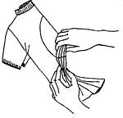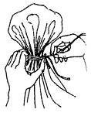

1. **ROSETTES**

A Rosette is many little circles, touching or overlapping each other. Using a pencil or your mind's eye, make a few dots on the cloth in any pattern. Each dot will be the center of a small circle, with the thumb and forefinger pick up dot after dot and transfer to the other hand. Wrap string or rubber bands several times around the base of all the circles which have been gathered together. Continue to wrap to the tip and back, making sure your ties are very tight.

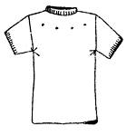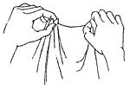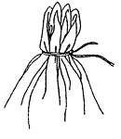

**Technique**

1. Select a theme/ source of inspiration
2. Make sketches of your composition on paper
3. Collect and prepare the materials and tools to be used.
4. Follow a method of your choice and tie the cloth, but make sure the knots are tight
5. Mix the dye in water and boil according to their instructions.
6. Dip the cloth in the first color of the dye
7. Remove the cloth and dry it in a cool dry place to prevent it from fading.
8. When the cloth is dry, tie it further in the areas you want to retain first colour and dip in another dye
9. Dry the cloth and go through the same process for the third time until the desired design is got
10. Untie the cloth and rinse in water to get rid of excess dye
11. Dry the cloth and iron it
12. **Stitchery/ sewing**

This is a method of tie and dye where threads are sewed in the patterns drawn on the fabric and tightened in order to resist the penetration of dyes.

Begin by sketching the required pattern on paper with a pencil and the trace the sketch on the cloth. Using a sizable needle with a tread and saw the patterns. The treads can be left hanging at the beginning and at the end of each stitch.

**Techniques**

* Select a theme and source of inspiration
* Sketch your design out using a pencil on paper.
* Collect and prepare the materials and tools to be used.
* Transfer the sketch of your design out using a pencil on the fabric and create contours.
* Use a large needle and nylon threads stitch through the contours of the design by using running stiches.
* Tie a very thick knot at the end of the thread to prevent them from falling out.
* One stitch at a time, pull the fabric back towards the knot until it is bunched up. Pull the fabric as tight as possible. Secure the thread with another thick knot.
* Mix the dye according to the dye instructions
* Dip the fabric in the first colour of the dye.
* Dry in a cool dry place to prevent the dye from fading
* Pull other stiches in places you want to retain the first colour and dip in second colour of dye
* Dry the cloth and go through the same process until the design is got.
* Cut the stitches out to reveal your tie dye patterns.

**BATIK**

Batik is a "wax resist" process for making designs on fabric/ a wax resist method of decorating a fabric. Hot wax is applied to portions of the fabric and penetrates the cloth. After the wax dries, it prevents the dye from spreading to those areas of the fabric that have been waxed.

**Materials**

* Wax
* Fabric
* Dye
* Water and soap

**Tools**

* Heat source
* A flat surface as a work area
* Papers
* Flat iron / iron box
* Pencils
* Tjanting tool
* Brushes different sizes
* Sauce pan
* Containers

**Techniques/methods**

1. **OUTLINES AND FILLINGS**

Hot wax is brushed on the fabric to fill solid shapes or to outline patterns. The lines can be varied in thickness and directions by controlling the flow or wax, a brush or tjanting tool is used.

**Steps**

1. Select a theme and make sketches of the composition on paper.
2. Collect the materials and tools to be used.
3. Lay the cloth on flat surface and transfer your sketch on the fabric.
4. Prepare the dye according to the dye instructions
5. Melt the wax in a container
6. Using a brush or tjanting tool apply wax on all areas you would like to maintain white and apply the first colour of dye to the entire cloth
7. Spread the cloth to dry in a cool dry, to prevent wax from melting and the dye from fading.
8. When the cloth is dry, apply more wax to places where you want to retain the first color of the dye and dip in the second colour of dye.
9. Spread the cloth to dry in a cool dry, to prevent wax from melting and the dye from fading.
10. When you are done with the design you want, Remove the wax from the cloth by squeezing and creasing the cloth
11. Lay several layers of paper on a flat surface and the put the cloth on top. Cover the cloth with other papers and iron, keep on changing the paper until the excess wax is removed
12. **CRACKLED AND MARBLED EFFECT**

A fabric can be completely waxed then crackled and dyed to produce a cracked or marble effect.

**Steps /processes**

1. Select a theme and make sketches of the composition on paper.
2. Collect the materials and tools to be used.
3. Lay the cloth on flat surface and transfer your sketch on the fabric.
4. Prepare the dye according to the dye instructions
5. Melt the wax in a container
6. Using a brush or tjanting tool apply wax on all areas you would like to maintain white and apply dye to the entire cloth
7. Spread the cloth to dry in a cool dry, to prevent wax from melting and the dye from fading.
8. When the cloth is dry, apply more wax to places where you want to retain the first color of dye, do this until the design is complete.
9. When you are done with the design you want, apply wax to the whole cloth and the crackle the cloth when the cloth dries. Cracking is creating cracks in the wax on the cloth and paint the cloth with a dark color
10. Dip the cloth in a dark colour preferably black and spread it out to dry.
11. Remove the wax from the cloth by squeezing and creasing the cloth.
12. Lay several layers of paper on a flat surface and the put the cloth on top. Cover the cloth with other papers and iron, keep on changing the paper until the excess wax is removed
13. **TEXTURED EFFECT**

This is the creating of texture effects in a batik artwork.

Steps

* 1. Select a theme and make sketches for the composition on paper
  2. Collect and prepare the materials to be used.
  3. Prepare the dye according to the dye instructions.
  4. Lay the cloth on flat surface and transfer your sketch on the fabric
  5. Place the cloth on a rough surface and rub wax on areas you would like to maintain white and apply dye to the entire cloth.
  6. Spread the cloth to dry in a cool dry, to prevent wax from melting and the dye from fading.
  7. When the cloth is dry, rub more wax to places where you want to retain the first color still on a rough surface.
  8. When you are done with the design you want, Remove the wax from the cloth by squeezing and creasing the cloth
  9. Lay several layers of paper on a flat surface and the put the cloth on top. Cover the cloth with other papers and iron, keep on changing the paper until the excess wax is removed.

1. **SCRATCHED EFFECT**

The fabric is waxed and then scratched with a blunt instrument to produce fine lines.

Steps

* + 1. Select a theme and make sketches for the composition on paper
    2. Collect and prepare the necessary materials and tools to be used.
    3. Lay the cloth on flat surface and transfer your sketch on the fabric.
    4. Mix the dye according to the dye instructions.
    5. Melt the wax in a container
    6. Using a brush or tjanting tool apply wax on all areas you would like to maintain white and apply the first colour of dye to the entire cloth
    7. Spread the cloth to dry in a cool dry, to prevent wax from melting and the dye from fading.
    8. When the cloth is dry, apply more wax to places where you want to retain the first color and dip in the second colour of dye.
    9. Apply the entire cloth with wax and scratch through the wax with a pin or any other blunt instrument and dip the cloth in a dark colour.
    10. When you are done with the design you want, Remove the wax from the cloth by squeezing and creasing the cloth
    11. Lay several layers of paper on a flat surface and the put the cloth on top. Cover the cloth with other papers and iron, keep on changing the paper until the excess wax is removed.

**EMBROIDERY**

This is a sewing technique used to decorate fabrics with a needle and a thread; it can either be achieved by machine or by hand

**TOOLS**

* Needles
* A pair of scissors
* Thimble, a small cap which fits over the middle finger
* Frame

MATERIALS

* Threads of different colors
* Fabrics

**STITCHES**

A stitch is a single pass of a needle in a fabric when sewing. There are a number of stitches used in embroidery quilting to give a fabric an interesting design depending on the purpose and type of design, and these include;

1. **Straight/Running stitches**

This is where a needle is inserted in and out of a fabric to form a horizontal line of stitches. This type of stitch is used to outline patterns, joining fabrics gathering and for plain steams.

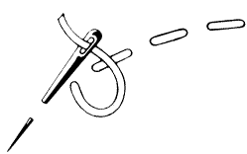

1. **Blanket or buttonhole stitch**

. To work the ordinary buttonhole stitch, bring the needle through at the left-hand end of the traced line, hold the thread down to the left with the thumb and insert the needle as shown in the diagram, draw it through over the held thread to complete the stitch. This stitch is used for over sewing blanket edges and for button-holes, and for decorative work to give a three- dimension effect

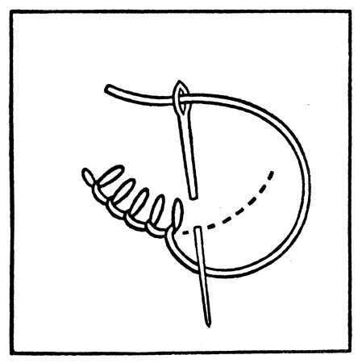

1. **Steam stitch**

The thread is kept to the same side of the needle, either to the left or to the right as better suits the purpose in hand; the effect is more line-like when it is kept to the right.

Stem stitch, well known and frequently used for various purposes, such as for lines, outlines, gradated and flat fillings. If a broad line is required the needle is put in more obliquely, and a raised effect can be obtained by working over a laid thread.

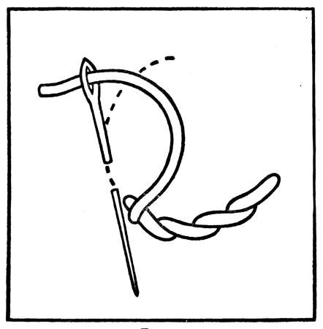

1. **Split stitch**

To work it, bring the thread through the lower end of the traced line, then insert the needle about one-eighth of an inch further along, and bring it through on the threads nearer the starting-point and also through the centre of the working thread, which thus splits each stitch.

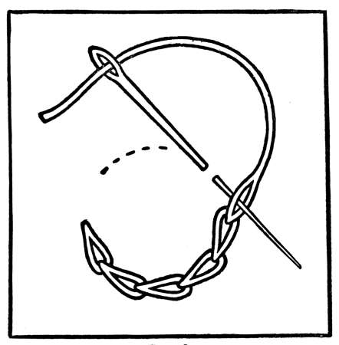

1. **Satin stitch**

These stitches lie closely together and in parallel lines, the difference between satin and several other closely allied stitches being that these others may radiate or vary in direction according to the space to be filled. The stitches may vary in length, they must neither be impracticably long nor, on the other hand, too much cut up.

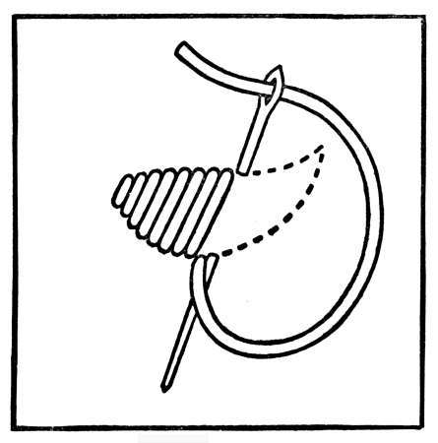

1. **French notes**

To work the French knot, bring the thread through the material at the required point, take hold of it with the left finger and thumb near the starting-point (A on plan), then let the point of the needle encircle the held thread twice, twist the needle round and insert it at point B on plan, draw the thread through to the back, not letting go the held thread until necessary.

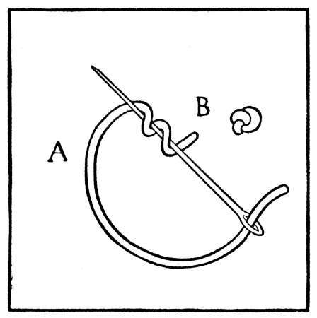

1. **Back stitch**

Back stitch sometimes makes a good line or outline. To work it, bring the needle through one-sixteenth of an inch from the end of the traced line, insert it at the start and bring it through again one-sixteenth of an inch beyond where it first came out. Each stitch will be seen starting at the point where the last one finished.

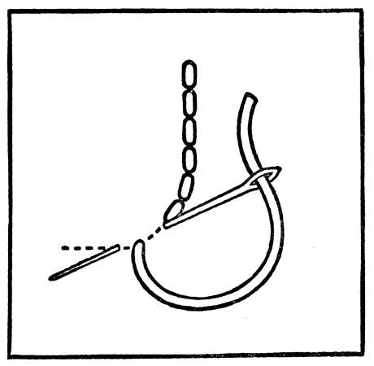

1. **Feather stitch**

The feather stitch, often used to decorate plain needlework, The stitch is so simple and so much in use as hardly to need description: There can be many slight variations of the stitch, the worker perhaps devising them needle in hand.

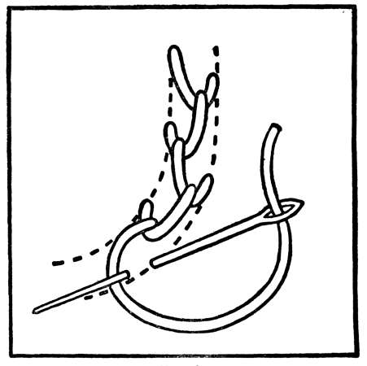

1. **Overcast stitch**

To work it, run or couch down a thread on the traced line, then with fine thread cover this over with close upright stitches, picking up as little material as possible each time in order to make the line clear and round. The stitch is worked most perfectly in a frame

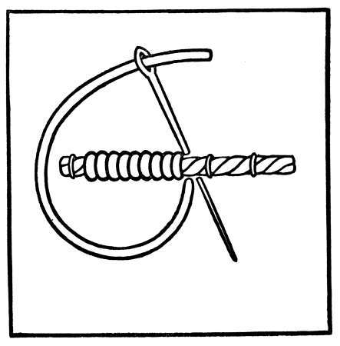

1. **Braid stitch**

With braid stitch, trace two parallel lines upon the material about an inch apart, and bring the thread through at the right-hand end of the lower line.

Throw the thread across to the left and hold it slackly under the thumb. Place the needle pointing towards the worker under this held thread, and then twist it round towards the left and over the held thread until it points in the opposite direction. It will now have the thread twisted loosely over it.

Insert the needle on the upper line an inch from the starting-point, and bring it through on the lower line exactly underneath. Place the thumb over the stitch in process of making and draw the thread through as the diagram shows. It can be worked openly or more closely as preferred.

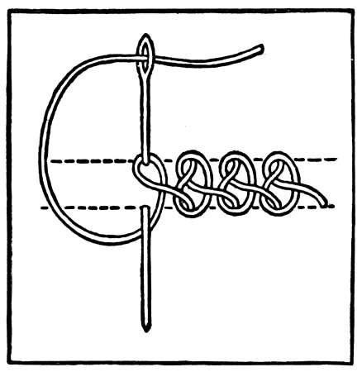

1. **Cable chain stitch**

Cable chain has very much the appearance of a chain laid upon the material, rather too much so perhaps to be a pretty embroidery stitch.

To work it, bring the needle through at the top of the traced line, throw the thread round to the left and hold it down with the thumb near where it has come through the material. Pass the needle under the held down thread from left to right and draw it through until there is only a small loop left. Insert the needle in the centre of this loop, on the traced line about half an inch below the starting-point. Bring it out a quarter of an inch below and outside the loop. Take the thread in the right hand and tighten the loop that has now been formed and then pass the thread under the point of the needle towards the left. Place the left thumb over the stitch in process of making and draw the thread through; this will complete the first two links of the chain; to continue, repeat from the beginning.

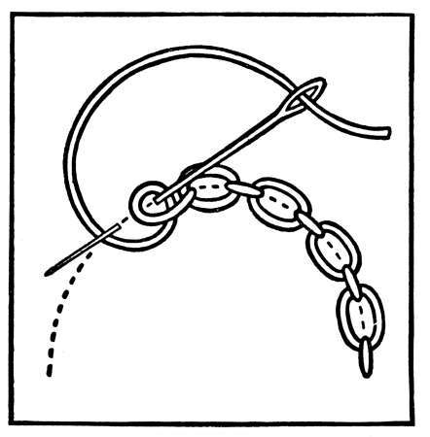

1. **Knotted chain stitch**

Knotted chain is a pretty stitch; to look well it must be worked with a solid thread. To carry it out, trace two parallel lines upon the material, about an inch apart.

Bring the thread through at the right hand end in the centre between the two lines, and then insert the needle on the upper line half of an inch further along, and bring it through on the lower line immediately below. Draw the thread through and there will be a short slanting line left upon the material.

Throw the thread round to the left and hold it under the thumb, then pass the needle and thread through the slanting line from above downwards, leaving the thread a little slack. Place the thread again under the thumb, then in the same way as before, from above downwards, pass the needle and thread through this slack loop. This makes the first two links of the chain; the last one will not be properly fixed in place until the next stitch is taken. The dotted vertical line on the diagram shows the piece of material taken up by the needle upon commencing the next stitch.

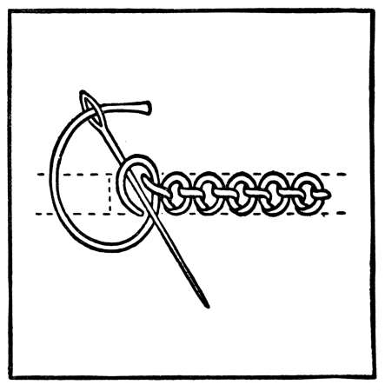

1. **Cross stitch**

This is used to create interesting effects on fabrics; the needle is inserted from right to left diagonally into the fabric so that a horizontal line of slanting stitches is formed. The cross is formed by taking the thread back across the previous stitches

**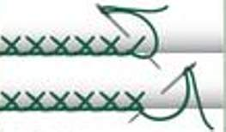**

**METHODS**

1. **Flat embroidery**

Patterns are drawn on fabric and embroidered with basic stitches

1. **Drawn threadwork**

This technique involves drawing threads from a piece of material. The areas where the threads has been removed are embroidered to give interesting effects

1. **Quilting**

This involves stitching together two layers of cloth. The padded fabric is embroidered to give a decorative surface

**Techniques/ process**

* Select a theme and a source of inspiration.
* Make sketches of your composition on paper and suggest the colors to follow.
* Collect the necessary materials and tools to be used.
* Transfer your sketch to the fabric to be embroidered.
* Using relevant stiches, embroider the fabric following the sketch.
* When complete, trim off the unwanted threads to give an interesting finish.

**APPLIQUÉ AND PATCH WORK**

**Patchwork**  
Patchwork is a form of needlework that involves sewing together pieces of fabric into a larger design. The larger design is usually based on a repeat pattern built up with different colored shapes. The shapes are carefully measured and cut to make them easier to piece together as blocks. When all the blocks have been joined together this is then known as the ‘top’.

**Materials**

* Pieces of colored cloth
* Sewing threads of different color

**Tools**

* Needles
* Thimble

**Techniques**

* Select a theme and source of inspiration
* Make sketches of your composition on paper.
* Collect and prepare the necessary materials and tools to be used.
* Cut out different designs and materials of colored fabrics and hem the hedges neatly making sure that each piece equals the rest
* Join the pieces together using a fine overstitch worked on the wrong side
* When complete, trim off the unwanted threads and fabrics to give an interesting finish

**APPLIQUÉ**

This is a method of fabric decoration in which pieces of a fabric are applied or fixed to another fabric to create a pattern. This method gives slightly raised patterns.

**Materials**

* Pieces of colored fabric
* Fabric
* Sewing threads of different color.

**Tools**

* Needles
* A pair of scissors
* Bowl
* Brush
* Frame
* Thumb tacks

**Methods**

There are several methods of appliqué:

* Reverse/ inverse applique, this is a method of applique where a design is cut out of a larger fabric and a different fabric is sewn below the gap.
* Direct applique. This is where a pieces of a fabric are sewn directly on top of the larger fabric.

**Techniques**

* Select a theme or source of inspiration for your applique
* Make sketches of your composition on paper
* Collect and prepare the materials and tools to be used.
* Cut out different colored fabrics according to your design and sketch
* The colored fabrics are then sewn onto the larger fabric/ ground fabric
* When complete, trim off the unwanted parts to give an interesting finish.

**WEAVING**

Weaving is the process of producing a fabric by interlacing a set of vertical threads (warps) with a set of horizontal threads (wefts) on a loom.

In general, weaving involves using a [loom](http://en.wikipedia.org/wiki/Loom) to interlace two sets of threads at [right angles](http://en.wikipedia.org/wiki/Perpendicular) to each other.

TOOLS

* Loom, this is a hand or machine operated device for weaving.
* Shuttle, it’s a tool used to interlace the weft threads through the warp threads.
* Beater, it is used to press the weft threads together.
* Cardboards
* Pair of scissors
* Sticks
* Nails

Materials required

* Threads
* Raffia
* Sisal

BASIC TERMS USED IN WEAVING

* **Warps,** these are threads that run vertically on a loom. These threads are usually static and kept at tension.
* **Wefts**, these are threads that run horizontally on a loom. These threads are dynamic and they interlace the warp threads.
* **A pick**. This is one weft thread.
* **Picking**: This is where the weft or pick is propelled across the loom by hand, an air-jet, a rapier or a [shuttle](http://en.wikipedia.org/wiki/Shuttle_%28weaving%29)
* **An end,** this is one warp thread.
* **Draft,** this is a plan made for the weaving process. Weaving drafts are standardized short-hand ways of explaining how to set up a loom to weave a particular weaving pattern.

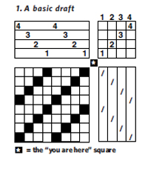

* **Shedding,** this is the process of separating warp threads to create space for the pick to run through.
* **Shed**, this is a gap (space) between the warp threads. The ends are separated by raising or lowering threads to form a clear space where the pick can pass
* Web, a piece of fabric decorated by weaving.

IMPORTANCE OF WEAVING.

* It’s a source of income and employment
* It expresses the feelings of an artist
* Weaving preserves culture and tradition
* It brings out someone’s creativity.
* It’s used in making and decorating fabrics Craft work helps us to occupy leisure time with a beneficial activity.
* For domestic functions like wearing and mats for sitting on.

**LOOMS**

A loom is a hand or machine operated device for weaving. Warp threads are stretched and kept at tension in order for the weft thread to be interlaced across the width of the fabric.

**TYPES OF LOOMS**

1. HAND LOOMS, these are looms that are manually operated or by use of hands e.g. frame loom, cardboard loom, inkle floor, back strap loom.
2. **THE RIGID HEDDLE LOOM**

Instead of creating a shed during weaving by using fingers to pick up the alternate upper and lower threads, a device called a rigid heddle is used to do this to speed up the weaving process.

A rigid heddle is composed of a row of slats themselves. Holes are drilled through the middle of each slat, warp threads are passed through the spaces and the slats. All the threads which pass through the slats are stationary while those that pass through the spaces are mobile.

The rigid heddle is moved up and down for each shed. When the heddle is depressed all the moveable threads slide up so that the stationary threads are below , and when the heddle is pulled up all the threads move down so that the stationary ones slide on the top.

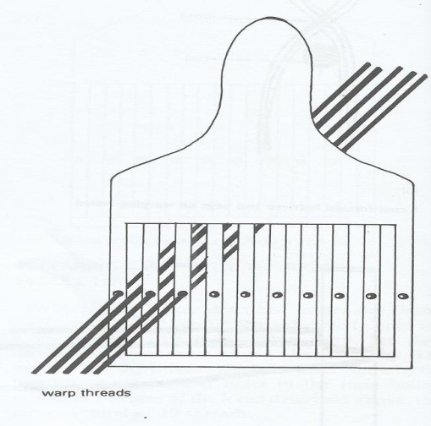

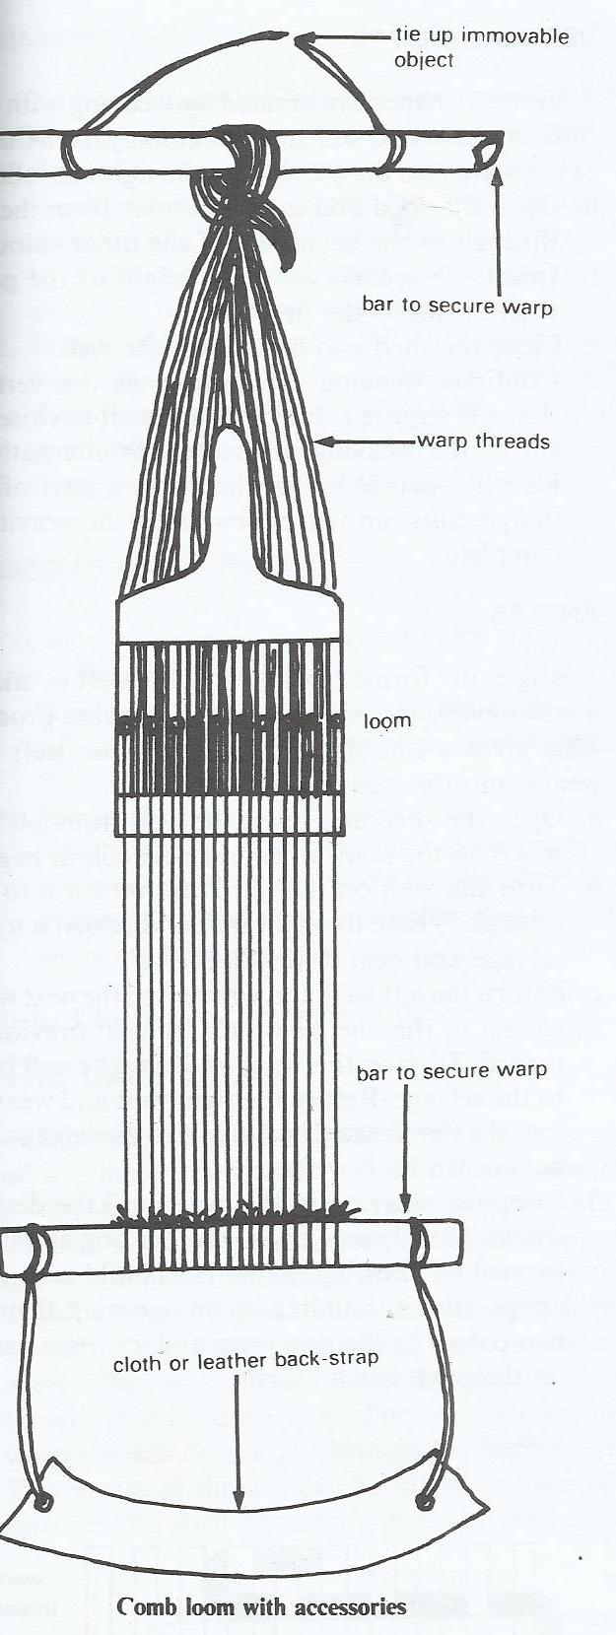

1. **THE INKLE LOOM**

This is a portable loom which consists of a simple frame work on which are mounted horizontal pegs at horizontal at certain intervals. The warp is wound around these pegs in continuous circle; the pegs themselves provide the required length of the warp.

String heddles, each looped around one of the pegs at the front part of the loom and over every other warp thread, hold this group of warp threads in a fixed position. The alternate group of warp threads don’t go through the heddle loops. This group of threads can be raised or lowered to provide the shed through which the weft thread passes.

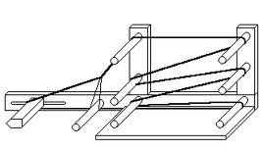

1. **FOOT-TREADLE/FLOOR LOOM**

A foot-treadle/ floor loom is fundamentally used with a foot or feet as well as hands (almost like a traditional sewing machine). With a floor loom, the weaving action requires both hands and feet. The feet take over half the work and the hands are free to manage the shuttle. Floor looms are also larger and stronger and they also provide more stability and permit the use of stronger belts of threads. It makes it firm and the textile becomes durable, hence foot pedals on a foot-treadle/ floor loom are used for raising and lowering warp threads during weaving.

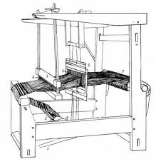

1. **BACK STRAP LOOM**

This is a portable and very simple to make. The procedure of using a back strap loom requires a weaver to fasten one of its two sides around the waist. The other end gets tied to a pole. During weaving, the pressure applied can be modified by only bending backwards little by little.

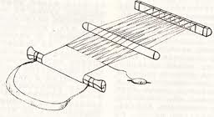

1. **A SERRATED CARDBOARD LOOM**

This is made using hard paper, the top and bottom sides have got to be notched. The long narrow cuts slits hold warp yarn running around up and down. This type of loom produces small trial weaves by reason of the paper’s rigidity. Cardboard looms are capable of producing an intricate example of a weave

**Making a simple weave using a card board**

The basic tools and materials are strings of natural fiber such as sisal, pencil, a card board paper and a cutter.

* Create equally spaced markings of 1cm at the top and bottom sides of a cardboard box in equal dimensions and sizes
* Cut open each marked area and create gaps in which warp yarn shall be fitted during weaving. The attained cuts may be triangular or just straight from a single cut.
* Pick a yarn and then roll or tie it well on one corner of the first narrow opening. Fit it up and down in each cut slit on both ends of a card board and fill it with warp yarn.
* Use a needle or a similar object to fit in weft yarn and Carefully start to weave by interlacing the weft yarn through the warps, side by side using a needle in a continuously way.
* When complete, fasten or cut off all loose ends of the thread to finish the weave

**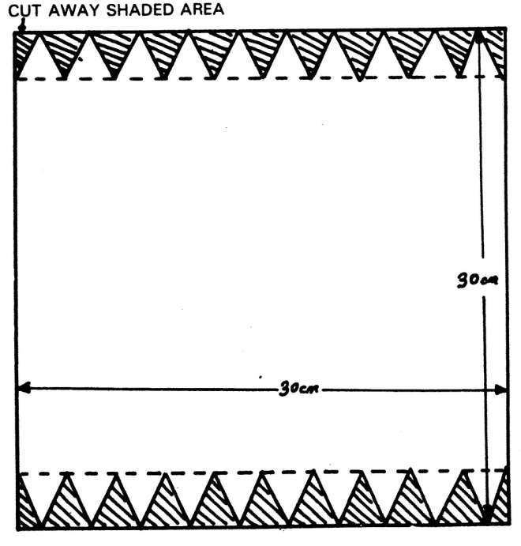**

**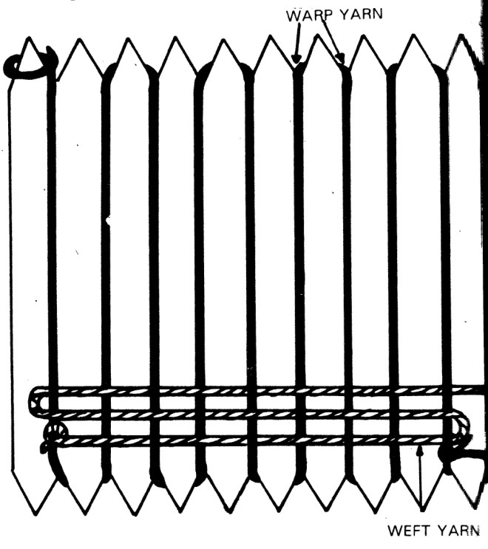**

1. **A FRAME LOOM/ HAND LOOM.**

It is made up of four wooden sticks attached on each other at right angles. There are two types of frame looms; one type has nails on all the four sides and other has nails on only two opposite panels but in equal spaces and straight lines.

The nails are used to hold warp yarns which may be wounded to run up and down. 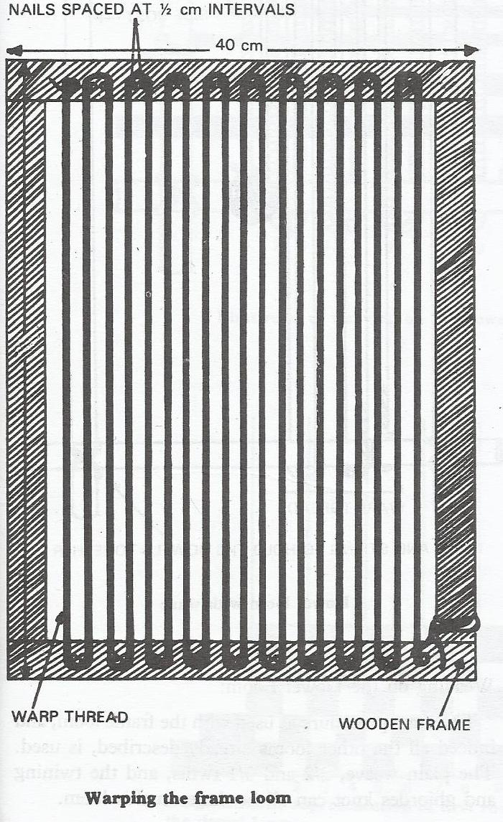

1. **GROUND LOOM**

This is made up of sticks or dowels hammered into the ground to support stretched out warp threads. The weaver uses weft threads at right angles, horizontally by hands. Using a ground loom necessitates a weaver to sit and bend forward since the loom is usually fastened and or set up down on the ground. Ground looms can be used to weave a pile, straps and bands, as well as flat-woven carpets or rugs.

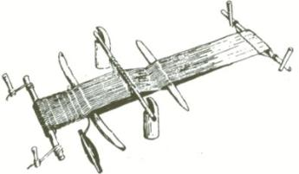

1. Power looms. These are looms that use a powered shuttle to insert weft threads into the warp threads.
2. Air jet looms. These are looms where weft threads are inserted by warm air.
3. Water jet looms. These are looms that use water jet technology.

**Techniques/ types of weaves**

There are many techniques in hand weaving, and it depends on the type of fabric being woven because various techniques produce various types of weave structures

1. **Plain weave**

Also known as **tabby or taffeta weave** is basically one that involves one weft thread going under one warp thread and under another warp thread in succession across the width of the cloth.

Types of plain weaves

1. **Balanced weave**

This is a type of plain weave were warps and wefts show equally

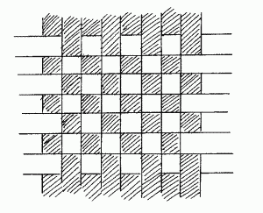

1. **Warp faced weave**

This is a type of plain weave were there are so many more warp threads than weft threads that the weft is all but covered by the warp.

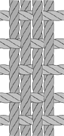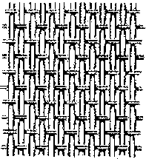

1. **Weft faced weave**

This is a type of a plain weave were the warp is all but covered by the weft. To accomplish this, space the warps far enough apart that the rows of weft will pack down and cover them.

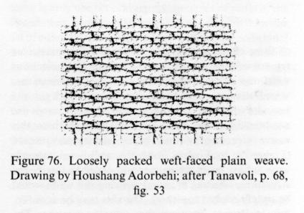

1. **Twill weaves**

Twill weave structures create diagonal lines of pattern in the cloth. These types of weaves create floats of wefts over a number of warp threads. There are two basic types of twill weaves;

1. **2/2 twill, also known as a balanced** weave because both the right and wrong side of the cloth appear identical. It’s when one weft thread runs over two warp threads, under two, over two, under two across the width of the fabric

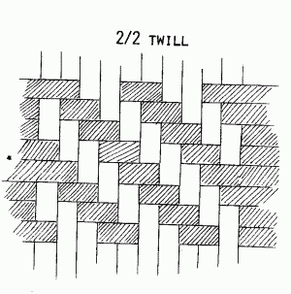

1. **3/1 or 1/3 twill. Also referred to as an unbalanced.**

It’s when one weft thread runs over three warp threads, under one, over three, under one across the width of the fabric.

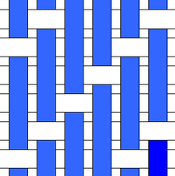

1. **Ghiordes knot**

A knot is tied around two adjacent warp threads, and each raw of knots is followed by a row of plain weave which holds them in place.

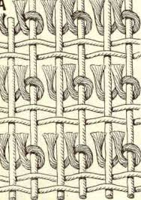

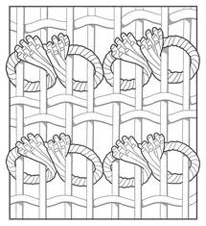

1. **Twining weave**

This technique is a form of chaining, where two weft threads across every time they entwine a warp thread, a figure of eight is formed around the warp threads. The twining weaves gives a very dense cloth, so it’s suitable for rugs and carpets. Plain weaves can be combined with it to produce unusual effects.

The twining technique is used to weave baskets and rugs.

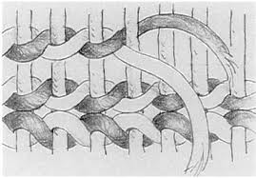

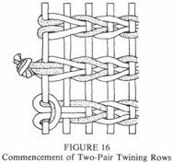

1. **Satin weave**

In a stain weave, one warp yarn is floated over four or more weft yarns tied down with one thread resulting in a smooth face.

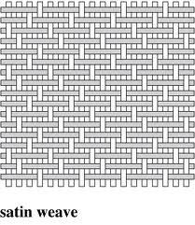

1. **Tapestry**

This is a weft-faced weaving technique where all the warp threads are usually widely spaced and hidden in the completed work, unlike cloth weaving where both the warp and weft threads may be visible. In tapestry weaving, weft yarns are typically discontinuous; colored wefts are interlaced back and forth their own small pattern area. It’s a plain weft-faced weave having weft threads of different colors worked over portions of the warp to form a design. There are various types of tapestry techniques some of which are discussed below;

1. **Slit**

This is a method where slits are left between sections of the weaving sections of weaving often between different areas of color.

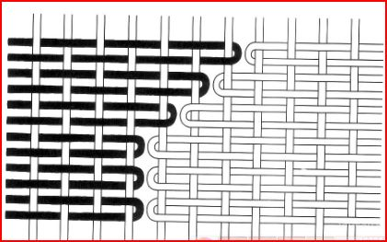

1. **Interlocking**.

Two shuttles are used together so that they interlock and form patterns where they meet.

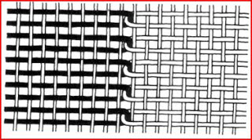

If it’s practiced on each row, it’s called double interlocking.

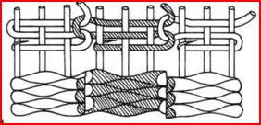

1. **Dovetailing**.

This is the kind of joining in which yarns adjacent to one another are brought around the same warp end before turning in the other direction to be woven in the next weft

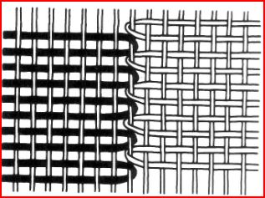

1. **Jacquard weave**

The jacquard weave combines aspects of the plain, twill and satin weaves. A jacquard fabric is woven on a jacquard loom to form a figure or design in of varying colours or texture. Many decorative fabrics are made by the jacquard technique.

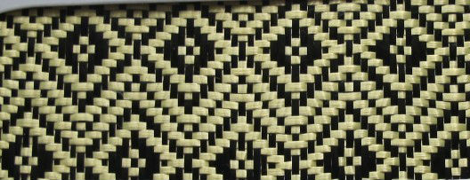

**BASKETRY**

This is the art or practice of producing baskets by interweaving strips of pliable materials such as cane, palm leaf, sisal e.t.c. using any of the basketry weaving techniques. It’s one of the oldest crafts in the world, and is closely related to cloth weaving.

**Materials**

* Palm leaves, papyrus reeds

**Tools**

* A sharp knife
* Awls

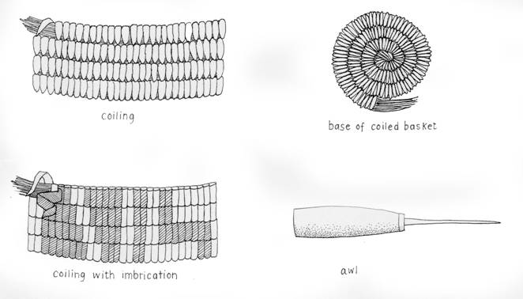

**Uses of basketry**

* Use of locally available materials effectively
* To earn a living
* For decorative functions
* For domestic functions like collecting food.
* Provides hands on practice
* They are used in entertainment
* Provides hands on practice
* They are used in entertainment Craft work helps us to occupy leisure time with a beneficial activity.
* To preserve culture and tradition

**TECHNIQUES**

**Wickerwork**

This type of basket work is often referred to as 'Wicker' or 'Stake and Strand' basketry. When looking at the sides of a basket, the straight upright sticks you can see are called the 'stakes'. On the base these stakes radiate outwards from the center and are generally called 'spokes' at that stage. Strands are woven between these rigid sticks to make an incredibly strong structure. Good work examples include flower baskets and trays. Wickerwork type of construction uses a stiff material such as cane, or reed as an inflexible warp and a more flexible material for the weft. Traditional granaries are made using this method.

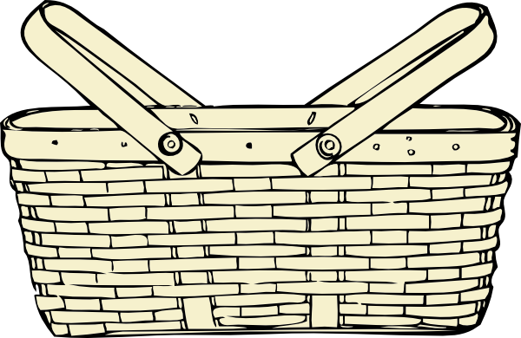

**Coil**

It is possible that the earliest basketry technique is the coil type. In which coils of materials such as straw, reed grass etc are wrapped with suitable material and sewn together to form a shape. The coils spiral from the base and successfully increase or decrease according to the shape and size being formed. These coiled baskets can be made so tight that they become water proof, especially if some sealing substance is put on them.

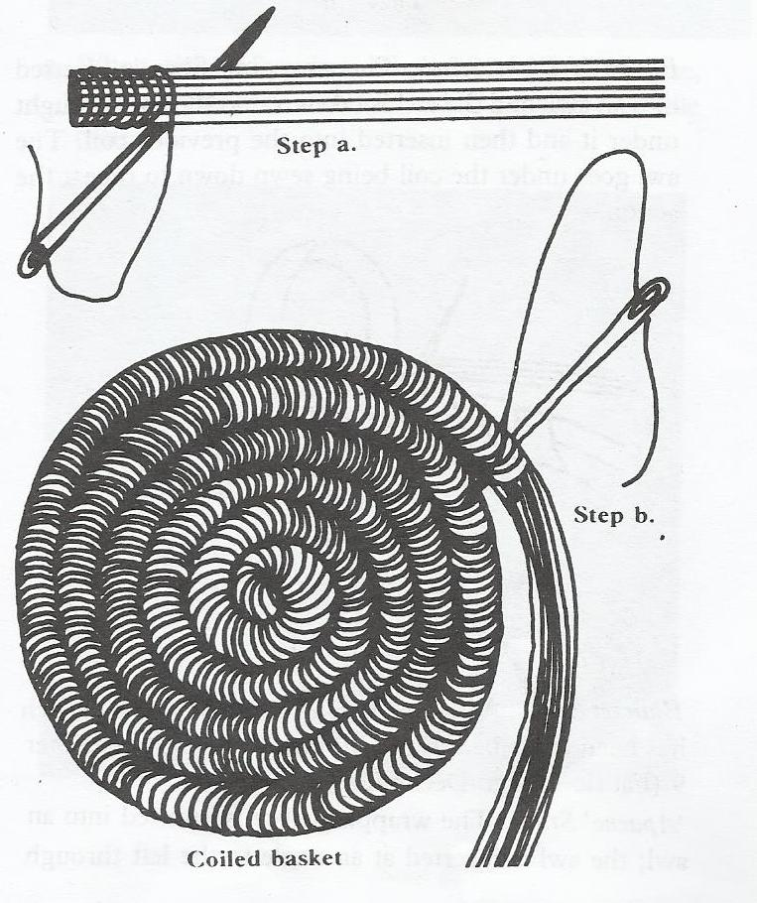

**Plaiting**

This is a straightforward technique in which the weft crosses over and under one warp at a time.  When a plaited object is flat, such as with a mat, it can be difficult to distinguish the weft from the warp.  The weft and warp of the plaited bottom can be split into smaller pieces and become the warp of the basket sides. Long strips are usually plaited and later joined together to form baskets.

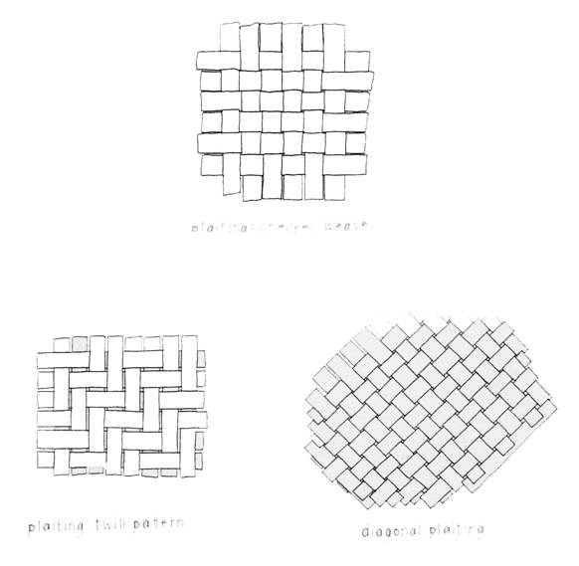

**Twining**

Twining is a technique in which two wefts cross over each other between warps.  There are numerous variations of twining, including variances in the number of wefts, the number of warps crossed by the wefts and the angle of the warps.

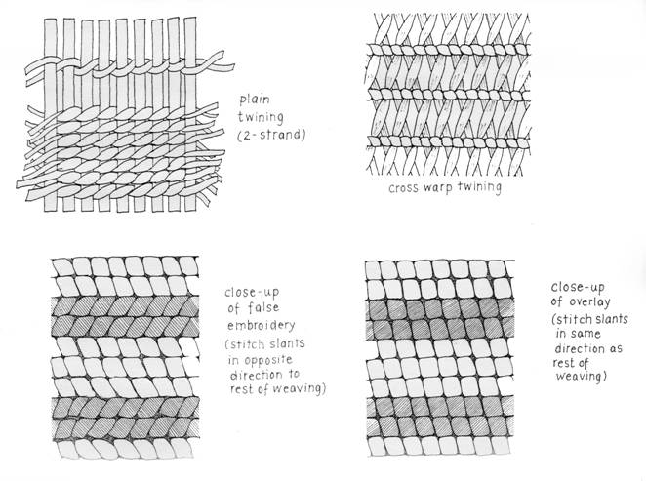

**PUPPETS**

Puppets are objects/ dolls used as characters in theatrical performances. Audiences perceive life and spirit from their movement, their shape, and other aspects of their performance. The Technical complexity of a puppet is only one element of a performance, however; other components of puppet performances include character, theme, plot, movement, and design.

Puppets were used for more than just entertainment, but also used for telling the stories of what happened in other cities to tourists. By the end of 18th century, puppets had gained more popularity around the world as a medium of spreading news and as a form of entertainment for children for children and adults alike. Puppet theaters became extremely popular in England and throughout Europe. Their popularity was taken to America through stories like Pinocchio and television shows.

Scholars believe that puppetry originated thousands of years ago, perhaps when prehistoric people placed their hands near a fire to cast shadows resembling animals, people, and imaginary creatures on cave walls. Most scholars agree that puppetry predates written language, and so we will never be certain how, why, or in what form the first puppets were created or used.

**TYPES OF PUPPETS**

The most common types of puppets are string puppets, rod puppets, hand or glove puppets, shadow puppets, and ventriloquists’ figures

* 1. **MARIONETTES/ STRING PUPPETS**

These are puppets operated by means of strings attached to their hands, legs, head and the body from a control, usually a wooden device held above the stage by the puppeteer.

Some marionette artists work their puppets in full or partial view of their audiences. In consequence, some marionette stages are large structures that allow puppeteers to manipulate their figures from behind and above the playing area. In such situations, the puppeteers are partially or fully concealed from the audience.

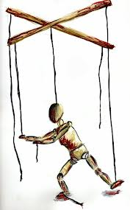

* 1. **Rod puppets**

These are controlled by rods attached to their limbs, heads, and bodies. Although the traditional rod puppets of Belgium and Sicily are worked from above, like marionettes, most contemporary rod figures are operated from below. 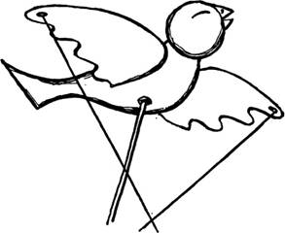

* 1. **glove puppets**

These are worn like a glove over a puppeteer's hand and arm. Much of a hand puppet's movement is controlled by the fingers and wrist of the operator. As with other types of puppets, some hand puppeteers prefer to appear in full view along with their puppets. Other hand puppeteers are hidden behind drapery or beneath the stage.

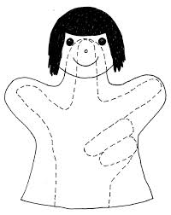

* 1. Sock puppets

A **sock puppet** is a [puppet](http://en.wikipedia.org/wiki/Puppet) made from a [sock](http://en.wikipedia.org/wiki/Sock) or similar garment. The puppeteer wears the sock on a hand and lower arm as if it were a glove, with the puppet's mouth being formed by the region between the sock's heel and toe, and the puppeteer's thumb acting as the [jaw](http://en.wikipedia.org/wiki/Jaw). The arrangement of the [fingers](http://en.wikipedia.org/wiki/Finger) naturally forms the shape of a mouth, which is sometimes padded with a hard piece of [felt](http://en.wikipedia.org/wiki/Felt), often with a [tongue](http://en.wikipedia.org/wiki/Tongue) glued inside.

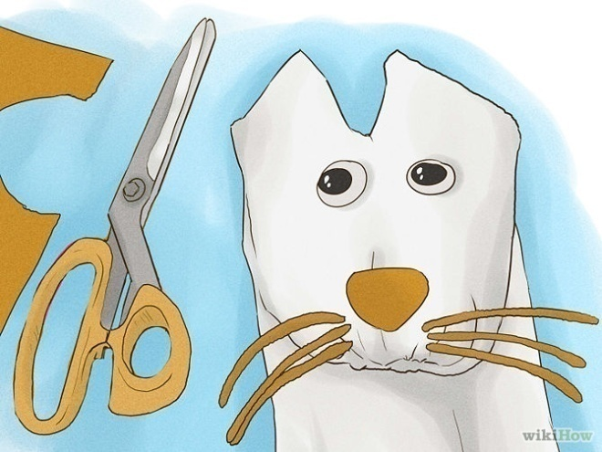

* 1. **shadow puppetry**

In shadow puppetry the shadows or translucent silhouettes of two- or three-dimensional figures are cast onto a white fabric screen. Usually the audience sits on one side of the screen while

the puppeteer manipulates the puppets on the other side of the screen in front of a light source. Variations on this style of puppetry have been especially popular in Asia for hundreds, and possibly thousands, of years.

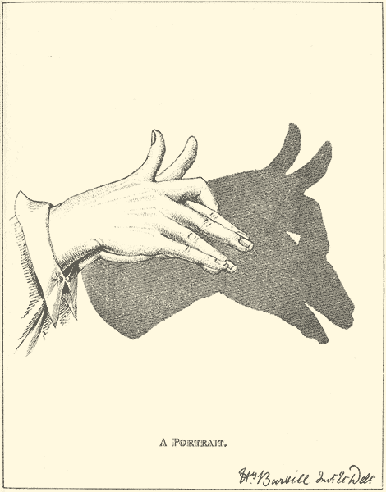

* 1. **Ventriloquists’ figures.**

They can be made of many kinds of material, and they usually share the stage with their animators (see Ventriloquism). Ventriloquists delight their audiences by mastering techniques of speech and of puppet manipulation that gives the impression that their figures are talking with them. Most ventriloquists’ puppets are manipulated by hand.

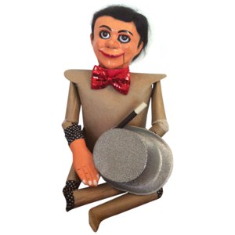

**Carnival or body puppet**

These are puppets designed to be part of large spectacles idealizing individuals, events. They are large and held by performers.

**Finger puppets**

These are simple puppets which fit on a single finger with no moving parts and consist of cylindrical forms or shape that cover the finger .it is used for story telling in kindergarten.

**Human arm puppet**

This form of puppet involves movement of fingers covered with some materials. It’s also known as two man puppet. It’s larger than hand glove puppet. It is operated by two puppeteers.

**Pull string puppets**

This consist of a cloth body where in the puppeteer puts his or her arm into a slot at the back and pulls a ring on strings that do certain tasks such as waving and moving the mouth.

**Push puppet**

Consist of segmental character on the base which is kept under tension until the button on the bottom is pressed .it wiggles, slumps and then collapses.

**Toy theater puppet**

The puppet is cut out of papers and stuck into cards .it is fixed at its base to a stick and operated by pushing it in from the side of the puppet.

**Table top puppet**

These are puppets usually operated by a rod or direct contact from behind on surface similar to a table top.

**Tickle bug**

It’s a type of hand puppet created from a human hand to have four legs where the puppet features are drawn on the hand its self .the middle finger lifted as a head the thumb and fore finger serve as first set of two legs on one side while the ring finger and little finger serves as second set of two legs on the opposite side.

**Water puppet**

This is form of puppet that dances on water with a rod that the puppeteers uses to control the movement.

**Other puppets include**; paper bug puppet, bent spoon puppet, moteker puppets, canvas puppets, marrote puppets, light curtain puppet.

**TECHNIQUES AND PROCESS**

**MARIONETTES/ STRING PUPPETS**

**Materials**

* Wood
* Small nails
* Binding wires
* Leather
* Nylons or cotton strings
* Colored cloth
* Paints
* Papier mache

**Tools**

* Hand saw, if the material is wood
* Pair of pliers
* Pair of scissors
* Painting brushes

**PROCESSES**

* Make sketches of the marionette to make and get the required materials
* form a piece of wire with loops on each end for the different body parts e.g. the thighs, legs, hands, arms, shoulders to act as joints for the marionette.
* Papier mache the wires to make the head, torso, legs, thigh, upper arm, lower arm and the hand to bring out their form.
* Join the body parts together using a wire and loosely so that they can freely move
* Paint and give it any extra texture or effects to make the marionette ready
* Create a control, a cross of wood and string up the marionette on the head and other body parts to the control.

**SOCK PUPPETS**

**Tools**

* Large needle
* Scissors

**Materials**

* Clean sock, long enough to fit in the arm
* Threads
* Decorating materials like buttons, beads, wool, felt material etc.
* Glue

**Processes**

* Choose a sock color depending on the type of character i.e. a striped sock will work best for a zebra.
* Glue or sew the eyes either at the bottom of the sock or at the toe end.
* Dress your hand in the sock to form the shape of the mouth using the fingers and the thumb.
* Cut a small triangle or circle to form a cute little nose. Either sew or glue it into place above the mouth
* **Finally, add on the extras!** Your puppet could have everything down to eyelashes, hoop earrings, bow ties, hair ribbons.

**ROD PUPPETS**

**Tools**

* pencil
* tag board
* dowels
* scissors
* hole punch

**Materials**

* markers, paints, and fabrics
* strong tape
* thin rods made of straightened coat hangers or wood
* paper fasteners

**Procedure**

1. Make sketches or draw the character on a piece of tag board.
2. Decide what parts of the puppet must move. Cut out the figure and the movable parts.
3. Use paper fasteners to connect the movable parts of the puppet.
4. Use strong tape to attach a rod to the back of the puppet. Add a rod to the back of each movable part so that you can control it. A very long puppet, such as a snake, can be controlled with one rod for the head and another for the tail.
5. Add yarn for hair, paint facial features, and add any other decorations needed to complete your puppet.

**IMPORTANCIES OR USES OF PUPPETS**

* Used for entertainment especially in theater
* Used for advertisement and TV programmes.
* Decoration especially in kids play centers
* Ceremonial or ritual celebrations like carnivals.
* In politics as dummies for contestants.
* They attract, capture attention to convey feelings and message.
* Used in teaching for dramatization or teaching aid especially in kindergartens.
* Religious and spiritual

**PAPIER-MÂCHÉ**

This is a [material](http://en.wikipedia.org/wiki/Composite_material) consisting of [paper](http://en.wikipedia.org/wiki/Paper) pieces or pulp, mixed with glue.

When papier mâché dries it is basically wood, and very strong and light. It is very popular as an inexpensive and versatile art medium.

**Materials**

* Paper
* Glue
* Water
* Paint

**Tools**

* Reinforcements e.g. wires
* Saucepan for boiling and soaking papers
* Mortar and pestle
* Sieve
* Paper cutters
* Paint brushes

**PREPARATION METHODS**

Two main methods are used to prepare papier-mâché;

## LAYERED PAPIER MÂCHÉ

This method makes use of paper strips glued together with adhesive on an armature or a mould.

* An armature is a frame work for a model used in sculpture i.e it supports the sculpture when being modeled)
* A mould is a device used to give materials the required shape.

**LAYERING TECHNIQUE**

* Select a theme and a source of inspiration
* Make a sketch of the composition
* Create papier mâché armature or mould
* Prepare the desired papier mâché paste/ glue
* Tear papers into strips
* Cover the mould with polythene papers to stop the papier mâché from sticking to it,
* Dip one strip at a time into prepared papier mâché paste and Stick it over the mould.
* Completely cover the form with a layer of strips overlapping each other. Layer the paper strips in alternating directions, to make the structure stronger.
* After a layer or two are applied, let them dry for 24 hours before more layers are added to get the desired layer effects. This avoids your shape buckling as it dries
* Paint and decorate finished form as required.

## PAPIE`R MÂCHÉ PULP

## This method for papier mâché is where paper is made into a sort of clay first, by soaking or boiling paper to which glue is then added and then used to mould things.

**HOW TO MAKE PAPER PULP**

* Select a theme and make sketches of your composition on paper
* Create the paper mache armature or mould to be used.
* Soak torn up or ripped up paper in a container of water overnight.
* When the paper softens, crush it into paper pulp using a blender or mortar. Only crush up a cup or so of paper at a time, and make sure there's plenty of water.
* Strain the mixture through a sieve. Gently squeeze out the extra water, but not too much. The pulp should be firm and damp, not hard and dry.
* Mix the pulp with glue, use cassava flour or wood glue.
* Apply the paper mache pulp over the prepared armature or mould.

**PURPOSES OF PAPIER MÂCHÉ**

* For making costumes, masks for festivals and other occasions
* Making toys
* Making props for schools and theatrical plays
* For decorations purposes

**POSSIBILITIES OF PAPIER MÂCHÉ**

* It’s a cheap material since it can be prepared from wasted paper
* It’s a light material

**LIMITATIONS**

* It requires a long preparation process in order to be used
* It cannot survive in moist environment
* Requires reinforcement for big pieces and areas of tension
* Can only be used indoors

**MASKS**

Theseare crafts made to imitate faces of different creatures. Or craft normally worn on the [face](https://en.wikipedia.org/wiki/Face), typically for protection, [disguise](https://en.wikipedia.org/wiki/Disguise), [performance](https://en.wikipedia.org/wiki/Performance), or [entertainment](https://en.wikipedia.org/wiki/Entertainment).

Some masks do represent realistic faces while others are a combination of different features of creatures to formulate a unique art work. The art of making masks is rich and has lived for a long time. In Africa there are tribes especially in the west where art creators spend most of their lives perfecting skills that are passed down from one generation to another.

**METHODS OF MAKING MASKS**

Mask making has various methods depending on the purpose which include;

* Wood carving
* Casting
* Papier mache

**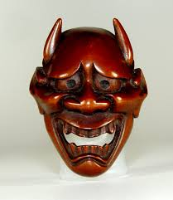**

**MAKING A MASK USING PAPIER MACHE**

**Tools**

* Knife for modeling
* Polythene papers
* Cutters
* Pair of scissors

**Materials**

* Clay or plaster
* Glue or paste
* Paints
* Found materials such as sisal, hair, seeds tree barks to make texture finishing
* Papers

**PROCESS**

* 1. Select a theme and source of inspiration and determine the type of mask you want to make, either realistic or abstract with a combination of different features of different creatures.
  2. Make a sketch of the composition
  3. Create the mould to be used.
  4. Prepare the desired papier mâché paste/ glue
  5. Tear papers into strips
  6. Cover the mould with polythene papers to stop the papier mâché from sticking to it,
  7. Dip one strip at a time into prepared papier mâché paste and Stick it over the mould.
  8. Completely cover the form with a layer of strips overlapping each other. Layer the paper strips in alternating directions, to make the structure stronger.
  9. After a layer or two are applied, let them dry for 24 hours before more layers are added to get the desired layer effects. This avoids your shape buckling as it dries
  10. When complete, let the papers dry and detach the mask from the mould
  11. Put the found materials to create features such as hair, whiskers, wrinkles, texture etc. paint to create tones to emphasize forms of the mask and finishing.

**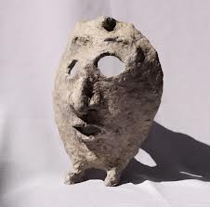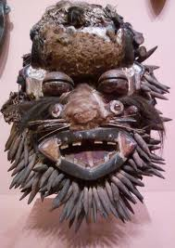**

**Uses of masks**

* decoration i.e. wall hangings
* entertainment i.e. drama, films, etc
* disguise to hide personality, character, mood and identity
* spiritual /worshiped as gods

**LEATHER WORK**

**DEFINATION**

Leather is a material made from various types of animal skins, such as calf skin, goat skin sheep skins, and skins of wild animals.

**TOOLS USED IN LEATHER WORK**

* Chalk
* a pair of scissors
* sharp knife-rags
* soft brush
* cotton ball
* skiving knife
* big needle
* u-shaped tool
* v-shaped tool
* a metal square
* Decorative tools
* dimple diamond
* out lining tool
* punching tools
* tracer stippler
* Small mallet
* matting tool
* squire mesh
* .

**TRADITIONAL ARTICLES MADE FROM LEATHER**

i.Masks ii.chairs iii. Shields iv.shoes v.bags VI. Belts vii. Sandals viii. Garments ix.ornaments, x.wallets xi. Earrings xii.bracelets xiii.necklaces xiv. Tables

**PROCESS OF FORMING LEATHER**

**Skinning**

The process starts with skinning the animal where the skin is removed from the slaughtered animal.

**Washing**

This involves soaking and washing the skin to remove dirt and impurities.

**Dehairing and fleshing**

The skin is softened by washing in lime to remove the hair and remain with the flesh.

**Cleaning**

The skin is subjected to another washing by scrubbing with a brush.

**Tanning and curing**

The skin is cured by subjecting it to a tanning process .the tanning chemical reacts with the natural gelatin in the pelt to form a water resistant substance .this process requires several weeks to turn the pelt into leather.

**Drying and compressing**

This involves airing and drying the pelt, after which it’s compressed under heavy rollers to give the leather firmness of texture.

**Furnishing**

It is the last stage which involves graining, where the surface is embossed with imitation, dyeing the leather and measuring to determine the size of leather.

**CATEGORIES OF PROCESSED LEATHER**

Leather can be categorized depending to the last stage of finishing

**Ordinary leather**

This is produced from pelt which has been produced without any major decorations or changes on theappearance.

**Suede**

This is soft leather which is produced by buffing the fresh of the leather.

**Embossed leather**

These are decorated with raised designs and can have many different types of designs created during the furnishing process.

**Patent leather**

This type of leather has a glossy highly furnished surface.

**Imitation leather**

This is decorated to imitate or resemble different animals or reptiles.

**TECHNIQUES USED IN LEATHER**

**There various techniques which can be used in leather work .these include**

a) Designing b) cutting c) moistening d) polishing e) skiving f) stitching

g) Scoring i) thonging j) stipping k) stamping i) matting m) modelling

n) Embossing o) incising p) tooling q) joining.

Designing

Designing involves shaping, weighing and measuring of leather that fits a particular article depending on the function. Patterns are drafted to be used as guides in the cutting process .these patterns are laid on the surface of leather and chalk marks are made round the shape and removed after which the leather is cut.

**Cutting**

It’s important to cut leather properly. The cut should be clean and the edges should be uniform .Avery sharp blade, knife, pair of scissors should be used.

**Moisturing**

It’s a technique of rendering hard leather soft and easy to cut .it’s done by laying leather on a flat surface and moisture applied with a rag or cotton ball. Care must be taken not to use too much water as this can damage leather .a void scratching or pushing sharp objects into the moistened leather as this will leave a permanent mark on the surface of the leather.

**Polishing**

Leather can be polished by applying wax on it and rubbing it with a soft brush until it is smooth and shiny.

A thin coat of polishing cream is applied with a cotton ball or soft rag and spread evenly over the surface of leather. A fresh rag is used to shine the leather. The wax helps to water proof the leather.

**Skiving**

This involves thinning down the edges of leather so that they are not bulky when being joined together. A square end skiving knife is used for this purpose .care should be taken not to make the skived edge too thin as it will tear during thonging or stitching.

**Stitching**

This technique involves sewing or joining two or more pieces together with threads. Stitching can be done by hand or by machine .care must be taken not to tear the leather when stitching.

**Scoring**

It’s a technique of making grooves a long a fold on leather .scoring leather helps to make folds or sharp bends in leather .v-shaped or u-shaped cutting tools are used .a metal square is used to guide the cutting tool so that a straight line is made .

**Punching**

It’s a technique of piercing leather to produce circular holes .these holes are used for stitching and fastening .it is also used to create patterns on leather .punching tools are used for boring holes and lottery punches are used for much larger holes, oval or irregular shaped holes can be cut with hand s tools such as knives or a very fine scissor.

**Thonging**

Thoging is a technique of producing a narrow strip of leather used as a lace for joining pieces of leather when making articles such as bags, shoes, wallets, and hand bags. A thong is a strip of leather.

**Stippling**

It’s a technique of creating patterns on leather by impressing a dot on its surface .the dots create depression in the surface of the leather .the depth and size of the depression in the surface of leather .the depth and size of depression can be varied to create different effects .a tool called tracer stippler is used for deep depressions the stippler can be tapped tightly with a small mallet.

**Stamping**

Stamping is a process by which are created patterns on the surface of leather. Tools with specific decorative designs are used .the stamping tool is held vertically on the leather and a wooden mallet is used to strike the tool gently but firmly to create the in print on the surface of the leather.

**Matting**

Is a technique of creating patterns on leather .this is similar to stippling .a matting tool with a number of points is used .two main examples of matting tools are the dimple diamond and the square mesh. The matting tool is held vertically on the surface of leather and struck with a wooden mallet to create the imprints.

**Embossing**

Embossing leather is a process in which raised designs are created on the surface of leather .a paper design is traced on the surface of leather which is then moistened with water .a ball is held under the leather and pressed firmly up wards .the leather is gently pushed to create a pattern .alternatively the leather is put on a sand pillow with the grain side facing downwards. The ball tool is used to press the motif down to the desired depth.

**Incising**

Incising means cutting into or engraving leather with a sharp tool .the design is traced on the surface of the leather and cut into the leather. The depth of the cut depends on the thickness of the leather .incising is used to create decorative allover patters or to create boarder patterns.

**Tooling**

Tooling is a process of marking on leather to create patterns with an out lining tool. The leather is first moistened and then the out lining tool is pressed firmly on the surface of leather to draw the lines. The lines can be deepened by going over them several times with the tool.

**Joining**

Its technique of binding together leather or joining using glue or by stitching .the glue must be specifically made for leather material and it must be able to bind well with the leather**.**

**TERMS USED IN LEATHER WORK**

**Pelt**

The protective covering of an animal.

**Hide**

The pelt of large animals

**Skin**

Refers to the pelt of smaller animals.

**Ways of decorating leather**

**Stippling;** this is the technique of leather decoration where patterns are created by the use of small dots to placed in different parts using a single point tool.

**Malting**; this technique is similar to stippling but differs in that tools with different points are used to place the dots that form the pattern.

**Leather stamping**; involves the use of shaped implements (stamps) to create an imprint onto a leather surface, often by striking the stamps with a mallet.

Commercial stamps are available in various designs, typically geometric or representative of animals. Most stamping is performed on vegetable tanned leather that has been dampened with water, as the water makes the leather softer and able to be compressed by the design being presses or stamped into it using a press. After the leather has been stamped, the design strays on the leather as it dries out, but it can fade if the leather becomes wet and it flexed. To make the impressions last longer, the leather is conditioned with oils and fats to make it waterproof and prevent the fibers from deforming.

**Modeling**; this is a decorative technique made by raising parts on the surface leather.

**Embossing;** this is a decorative technique made by raising parts of leather from underneath.

**Tooling;** this is a decorative technique made by pressing lines on the surface of leather